**Image-Guided Robotics System Thesis Final Report**

Supervisor: Professor Lueder Kahrs

By: Kevin Hu

Student Number: 1005797419

**Table of Contents**

**0 Abstract 7**

**1 Introduction 7**

**2 Literature Review 10**

2.1 History of Surgical Robots 10

2.2 Imaging Modalities 12

2.3 Introduction to Registration 13

2.4 Registration Explained 14

2.5 Alternative Imaging and Registration Techniques 16

2.6 Levels of Autonomy for Surgical Robotics Systems 17

2.7 Vision in Image-Guided Surgical Robotics 18

2.8 Project Introduction 20

2.9 ROS and 3D Slicer Integration 23

2.10 Image-Guided Robotics System Final Test and Evaluation 24

**3 Methods and Findings**

3.1 Franka Emika Panda Robot Testing 26

3.2 Control of Franka Emika Panda Robot 27

3.3 3D Slicer Markup Path Python Extension 28

3.4 Exploration of Slicer-ROS2-Module with Sensable Phantom Omni Robot 29

3.5 Exploration of Slicer-ROS2-Module with Panda Robot 30

3.6 Broadcasting the Robot State of the Panda Robot Using Franka_ROS2 Controllers 31

3.7 Software Implementation of a Raspberry Pi Camera V2 32

3.8 Adding the Raspberry Pi Camera V2 to the Environment 33

3.9 Image Registration using VoxelMorph 35

3.10 Training Data Collection and Image Registration Pre-training 39

3.11 Running the Code and Launching Nodes 44

3.12 Publishers/Subscribers and Topics 46

3.13 Slicer_ROS2_New Node In Detail 47

3.14 Image_Reg Node In Detail 50

3.15 Trace_Path Node In Detail 51

3.16 Camera_Pub Node In Detail 52

3.17 Calibration and Frame Transformations 52

3.18 Experimental Methods 55

**4 Results and Discussion 59**

4.1 Performance of Image-Guided Robotics System without Image Registration on Fixed Images 59

4.2 Performance of Image-Guided Robotics System with Image Registration on Moving Images With Constant Displacement 63

4.3 Performance of Image-Guided Robotics System with Image Registration on Moving Images With Constant Deformation 66

4.4 Discussion of Results and Sources of Error 68

**5 Conclusion**  **69**

5.1 Significance of Thesis 69

5.2 Possible Improvements to the Image-Guided Robotics System 70

5.3 Possible Future Work 70

**6 References 72**

**7 Appendix A (README File for Code) 79**

**List of Figures**

Figure I: An image-guided surgical robotics system 8

Figure II: MRI of the Axial, Sagittal and Coronal Views of the Human Brain 9

Figure III: Medical Imaging Software 3D-Slicer 10

Figure IV: Teleoperated Image-Guided Surgical Robotics System 11

Figure V: ZEUS Image-Guided Surgical Robotics System 11

Figure VI: Da Vinci Image-Guided Surgical Robotics System 12

Figure VII: A Comparison of MRI, CT Scan and Ultrasound Images 13

Figure VIII: A 3D Reconstruction of a Human Torso in 3D Slicer 14

Figure IX: Deformable Image Registration Flow Field 14

Figure X: Levels of Autonomy in Robotic Surgery 17

Figure XI: An Endoscope 19

Figure XII: Steps for Camera Calibration 19

Figure XIII: Epipolar Geometry for a Stereo Camera 20

Figure XIV: OAK-D Lite Stereo Camera and Raspberry Pi Camera V2 21

Figure XV: Raspberry Pi 4 Model B 22

Figure XVI: ROS-IGTL-Bridge Setup 24

Figure XVII: Slicer-ROS2-Module Setup Comparison 24

Figure XVIII: Franka Emika Panda Robot 27

Figure XIX: MoveIt2 Motion Plan Simulation of Franka Emika Panda Robot 28

Figure XX: 3D Slicer Extension to Select Markups and Output Path 29

Figure XXI: Sensable Phantom Omni Robot 30

Figure XXII: Phantom Omni in 3D Slicer 30

Figure XXIII: Franka Robot in 3D Slicer 31

Figure XXIV: Updated Qt UI 31

Figure XXV: Experimental Setup with Raspberry Pi Camera V2 34

Figure XXVI: VoxelMorph Model Architecture 37

Figure XXVII: VoxelMorph Architecture Based on UNet Layers 39

Figure XXVIII: Loss Curve of Training for MNIST Dataset 41

Figure XXIX: Moving, Fixed, Moved and Flow Images for MNIST Dataset 42

Figure XXX: Loss Curve for Training of Brain MRI Dataset 43

Figure XXXI: Moving, Fixed, Moved and Flow Images for Brain MRI Dataset 44

Figure XXXII: Node and Topic Graph for Image-Guided Robotics System 47

Figure XXXIII: Image of 3D Slicer Scene with Robot and Brain MRI 57

Figure XXXIV: Image of Experimental Setup with Robot and Brain MRI 58

Figure XXXV: Location of Fiducial Points for Experiment 59

Figure XXXVI: Requested vs Actual Position of Robot for First Experiment 60

Figure XXXVII: Error in Position of Robot for First Experiment 60

Figure XXXVIII: Error Magnitude for Each Point of First Experiment 61

Figure XXXIX: Requested vs Actual Position of Robot for Second Experiment 63

Figure XL: Error in Position of Robot for Second Experiment 63

Figure XLI: Error in Magnitude of Each Point In Second Experiment 64

Figure XLII: Requested vs Actual Position of Robot In Third Experiment 66

Figure XLIII: Error In Position of Robot In Third Experiment 66

Figure XLIV: Error In Magnitude of Each Point in Third Experiment 67

Figure XLV: Overview of SynthMorph 71

Figure XLVI: Overview of 3D AttriFlow 72

**List of Tables**

Table I: Hardware for Image-Guided Surgical Robotics Setup 22

Table II: Image-Guided Surgical Robotics Thesis Project Details 25

Table III: Data for First Experiment 62

Table IV: Data for Second Experiment 65

Table V: Data For Third Experiment 68

*Acknowledgements to my supervisor Professor Lueder Kahrs and to my family who I couldn’t have done this project without their support.*

**0 Abstract**

Image-guided surgical robotics systems are growing increasingly popular in the research domain. However, due to the lack of access to these systems because of expensive medical imaging equipment and software, many researchers are unable to pursue the research effectively. The goal of this project was to create an image-guided robotics system with open-source medical imaging and robotics software and a collaborative robot, the Franka Emika Panda robot. Another goal of the project was to incorporate state-of-the-art deformable image registration techniques to simulate problems with real image-guided robotics systems where a patient may move during an operation due to their breathing or the patient's tissues may be deformed due to application of certain surgical instruments. The CNN based deep learning model VoxelMorph is used for image registration that can output a deformation field given fixed and moving images. The medical imaging software 3D Slicer was integrated with ROS2 to create a live surgical scene in 3D Slicer. A path could be traced out using 3D Slicer markups where the robot should move by the operator. The results of the project determined that creating an image guided robotics system using open source medical imaging and robotics software and a collaborative robot was indeed possible especially for fixed images. The image registration showed promise and could be something that is explored further. The results found during this project opens the door for image-guided robotics systems to be introduced to the public at a faster rate.

**1 Introduction**

The use of image-guided surgical robotics systems in the medical robotics field is becoming increasingly common. Surgical navigation systems that execute predefined plans based on markups created by the user on 3D digital models and images are now used in a wide range of non-invasive surgical applications that require both imaging and accurate surgical tool placement [1]. The application of robotics systems to the medical field has dated back to the 1980s [2]. During the past few decades, new developments in the quality of surgical robotics systems have dramatically increased and their use has been widespread. However, new advances in technology has led to higher costs of medical robotics equipment. Currently, spending on medical robots consists of 57% of all service robots, including medical, logistics and field robots, at a cost of 12.6 billion USD per year [3]. Surgical robotics systems also do not only involve the robot itself, the system also requires expensive medical imaging hardware like CT scanners, MRIs and ultrasounds [4] to capture medical imaging data that a surgeon has to examine. Typically in surgical robotics applications, a large amount of imaging data from axial, sagittal and coronal views are required to create a full 3D reconstruction of a patient’s body. The surgeon only then can identify problem areas for which the robot to operate on. Thus, emerging research on these applications is difficult due to the high cost of surgical robotics and medical imaging hardware. In addition, there is a problem with the inaccessibility of medical imaging and robotics software due software licensing and the proprietary nature of the products. In order to access the medical imaging and robotics software, the full surgical robotics system must be purchased.

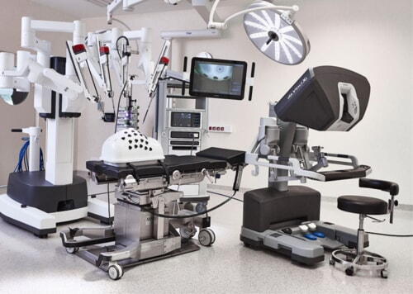 [5] Figure I: An image-guided surgical robotics system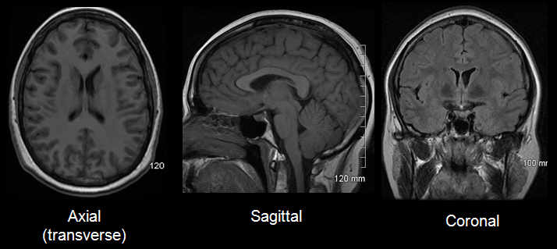[6] Figure II: MRI of the Axial, Sagittal and Coronal Views of the Human Brain

For scientists and engineers wanting to create their own surgical robotic systems for scientific research to progress the medical robotics field, there are a couple additional barriers other than cost. Many research institutions interested in the field of surgical robots have access to collaborative robots which can easily operate on the robot operating system (ROS) platform. Unfortunately, there are difficulties with interfacing robotics software with medical research software[1]. ROS has a wide variety of features useful for robotics applications including computer vision, kinematics, sensing, motion planning and simulation. However, surgical planning heavily relies on medical images to localize and identify affected areas required for treatment. Furthermore, these areas must be transformed from the images into 3D coordinate space. Many of these features are available in medical image computing and image-guided therapy software. As of now, ways of integrating ROS and medical imaging software are limited [7].The goal of this research project is to build an easily accessible image-guided surgery system using a collaborative robot, open-source software, and the state-of-the-art software algorithms to optimize surgical tool placement accuracy. The objective is to give medical robotics researchers higher accessibility to image-guided surgical robotics systems in order to progress the field at a faster rate.

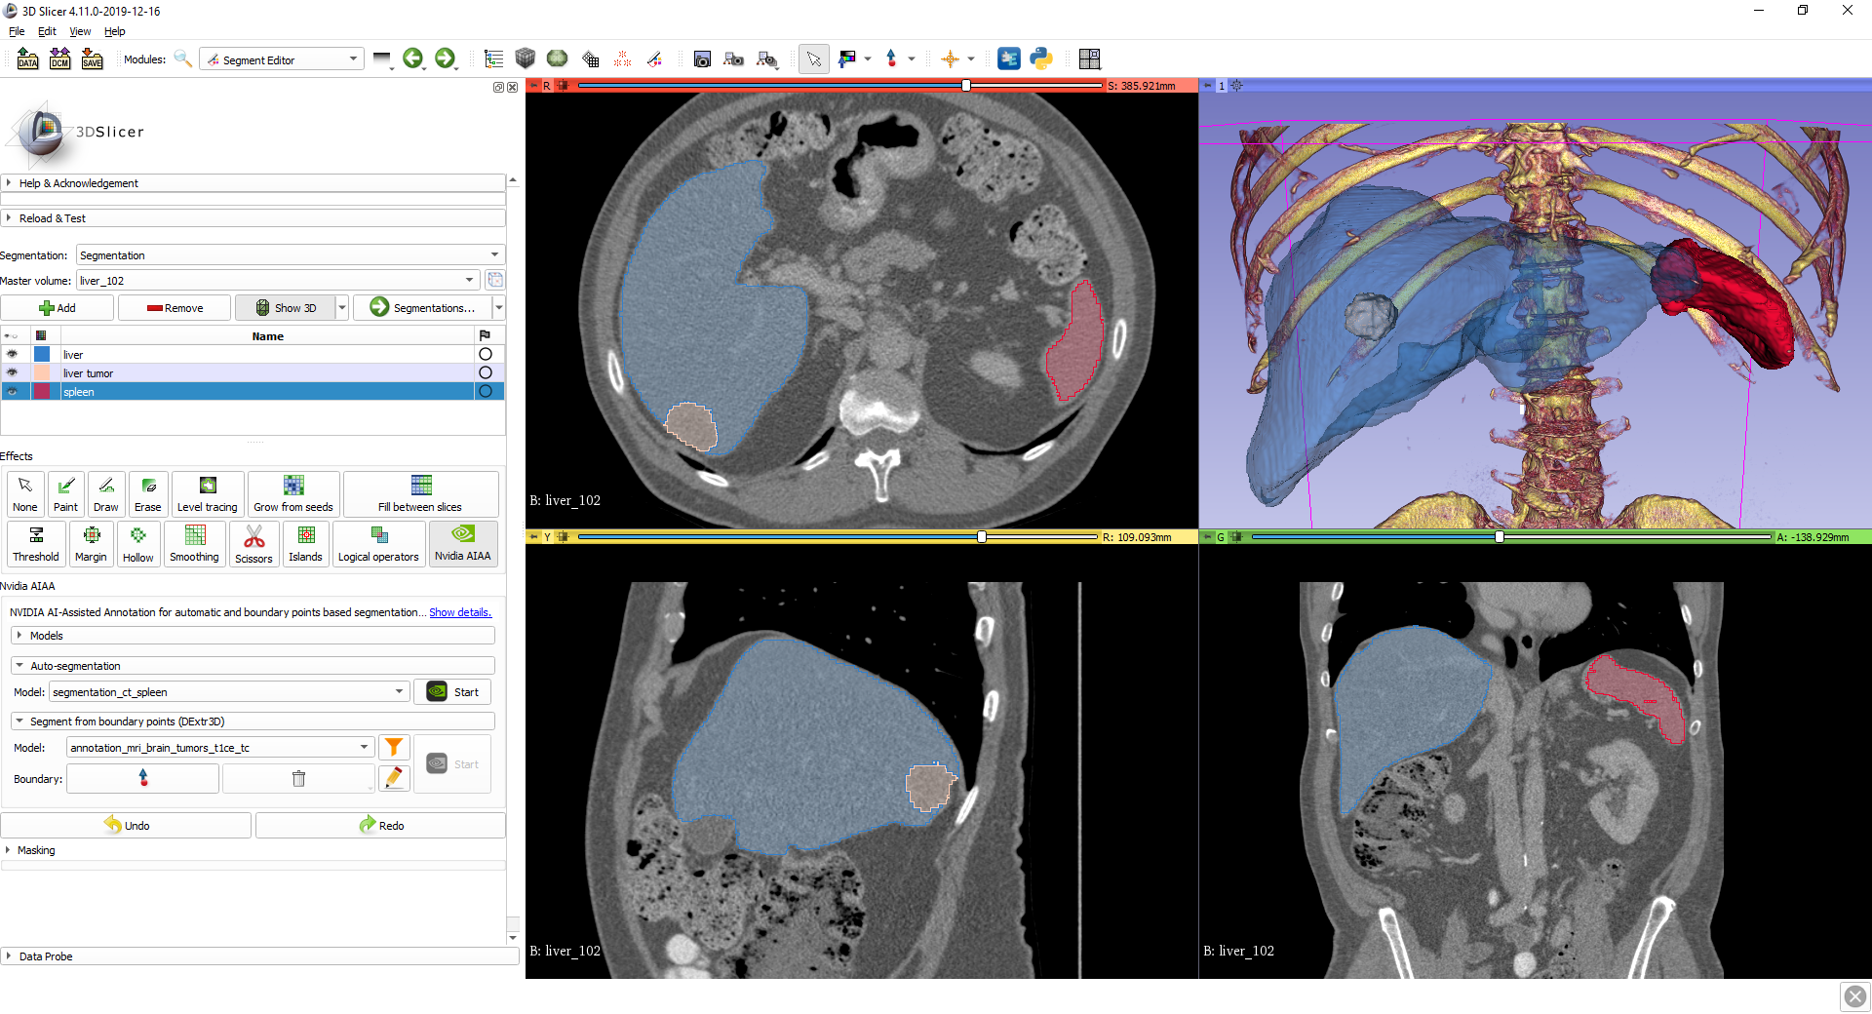[8] Figure III: Medical Imaging Software 3D-Slicer

**2 Literature Review**

2.1 History of Surgical Robotics

The use of robotics for surgical applications was suggested all the way back in 1967, but it wasn’t until 1992 that the first completely functional multipurpose surgical robot was approved by the FDA (Food and Drug Administration) and received FDA clearance [9]. There were earlier recorded uses of robots during medical procedures dating back to 1985. The procedure involved an industrial robot to perform brain biopsy with the help of CT imaging, but it was discontinued due to safety concerns [2]. In the late 1980s, an image-guided system for prosthetic hip replacement was used called Robodoc. During this period, there was an increasing popularity of stereotactic or computer-assisted systems and teleoperated robotic systems. Teleoperated systems are based on virtual reality (VR), where people could control and interact with images in a computer generated environment. Combining VR and robotics led to the development of the telepresence surgical system at the Stanford Research Institute where a surgeon's hand motions could control manipulators with surgical instruments that could be seen through a stereoscopic video monitor. Ultimately, the research was picked up by DARPA and never intended for human use or commercialization. In 1992, a start-up company called Computer Motion developed AESOP, a surgical robotics system for laparoscopic surgery, surgery inside the abdomen. Today, endoscopic research for laparoscopic surgery is one of the main uses for surgical robotics. Computer Motion also developed ZEUS, a 6 DOF remote surgical system for laparoscopic surgery in 1995 [9].

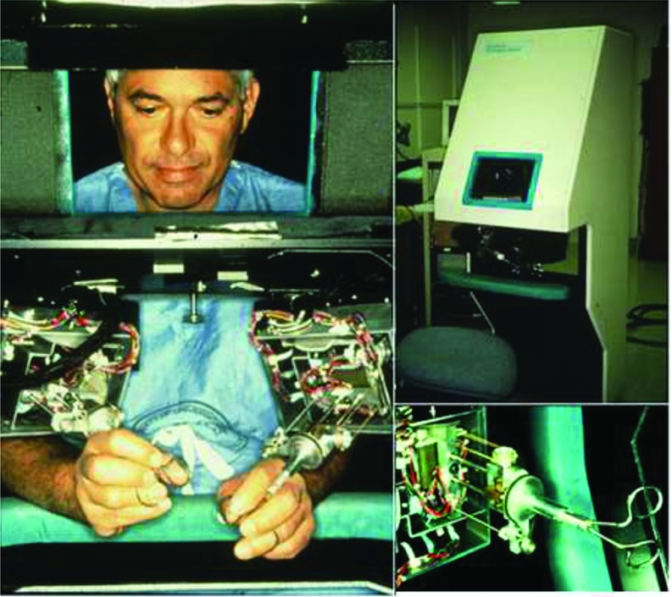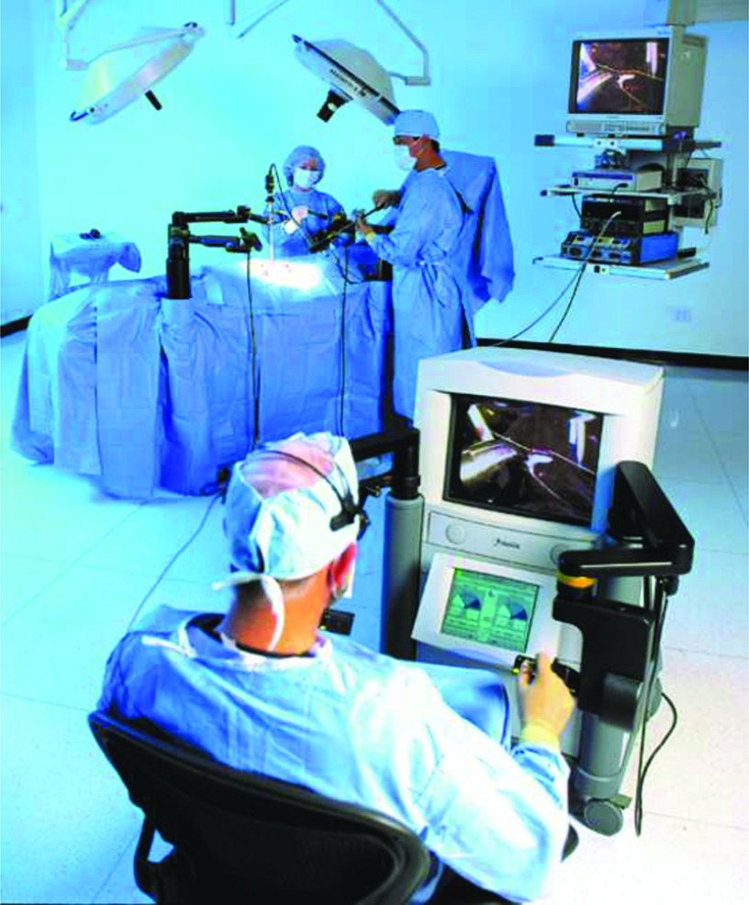[9] Figure IV: Teleoperated Image-Guided Figure V: ZEUS Image-Guided Surgical

Surgical Robotics System Robotics System

The most widely used and renowned surgical system is the Da Vinci Robotic Surgical system. The system combined both the ideas of telepresence surgery and laparoscopic surgery [10] and was developed by a start-up company called Intuitive Surgical. The defining features of this surgical system was that it allowed for minimally invasive open surgery using 3D video and 7 DOF wristed instruments that fit through small tubes similar to laparoscopy. The main concept of the Da Vinci system was a master-slave teleoperation architecture, where the surgeon console containing two master interfaces could control slave manipulators holding surgical instruments and endoscopes on the patient table. In between the surgeon console and the patient side manipulators was a computerized control system that transmitted images from the endoscopic cameras to the stereo viewer of the console and the surgeons hand movements measured by the master interfaces to the slave manipulators. Since the control system was electronic, it filtered out the surgeon’s normal physiological tremor and could create very precise motions [10]. Over the last two decades, development on new surgical robotics systems continued to increase and many systems took inspiration from the da Vinci robot model. Many research institutes use the da Vinci Robot Kit (dVRK), hardware from retired da Vinci surgical systems repurposed as research platforms to explore new ideas for minimally invasive surgery [11].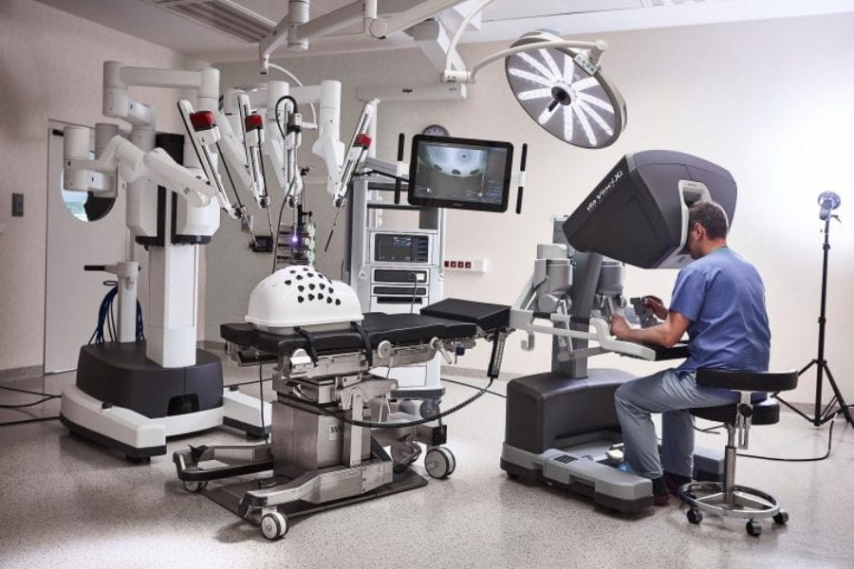[12]

Figure VI: Da Vinci Image-Guided Surgical Robotics System

2.2 Imaging Modalities

Many surgical robotics systems developed over the past few decades are image-guided surgical systems that perform image-guided robotic interventions. Image-guided robotic interventions combine robotic and medical imaging technology to perform surgical procedures [13]. The medical imaging technology most often used for image-guided robotic interventions are CT scans, MRIs and ultrasounds. However, some do classify VR related surgical systems like the da Vinci Robot as image-guided surgery as well [14]. CT guided interventions have high spatial resolution especially for high density like bone. It is most commonly used with head, neck, spine and lung interventions. A popular robotics system that uses CT scans is the ROSA One for brain and spine surgery. MRI guided interventions are able to provide 3D images with variable soft-tissue contrast, allowing for precision positioning of the probe while ensuring tissue classification. Ultrasound imaging guided interventions are widely available due to their low cost but the ultrasound probe must remain in contact with the patient throughout the intervention. Sometimes a combination of these three imaging modalities are used together to achieve a more accurate result [15].

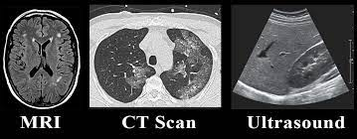

Figure VII: A Comparison of MRI, CT Scan and Ultrasound Images

2.3 Introduction to Registration

The most important aspect of an image-guided surgical robotics system is that it is able to create a 3D reconstruction of the world with the help of imaging data. The 3D reconstruction can then be seen either in software or on a VR console. The three medical imaging modalities are able to provide 3D imaging data and 2D imaging data by slicing the data into a series of 2D images from 3 different axes. However, the imaging technology only provides the data in their own coordinate system or frame. How are we able to get the data into the world coordinate system to create a 3D reconstruction? How is the world frame related to what is seen in software or VR? How do the imaging coordinate frames or the surface of the examined tissues change over time? These problems are solved using registration or image registration, one of the largest areas of research in the field of image-guided surgical robotics.

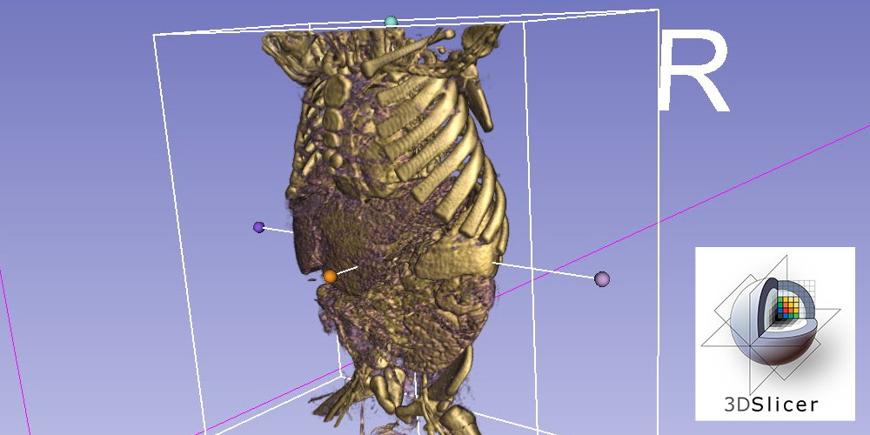[16]

Figure VIII: A 3D Reconstruction of a Human Torso in 3D Slicer

2.4 Registration Explained

Registration is the act of aligning two coordinate systems and determining the transformation between them. Most of the time for image-guided robotics, image registration is a topic of interest since an image has to be aligned with another coordinate system. There are some common scenarios for registration including image-device, registering pre-operative data to the patient/world space, inter-device, registering pre-operative data to a laparoscopic video feed and intra-device, registering feature points in one video frame to the next and finding the change in camera position [15]. Sometimes the surface of the examined tissue may change over time due to the patient breathing or deformation of the tissue due to application of surgical instruments. Images of the deformation over time can be registered together to determine the change in tissue surface and 3D reconstruction of the world. Images from different imaging modalities can also be registered together as well to determine their transforms.

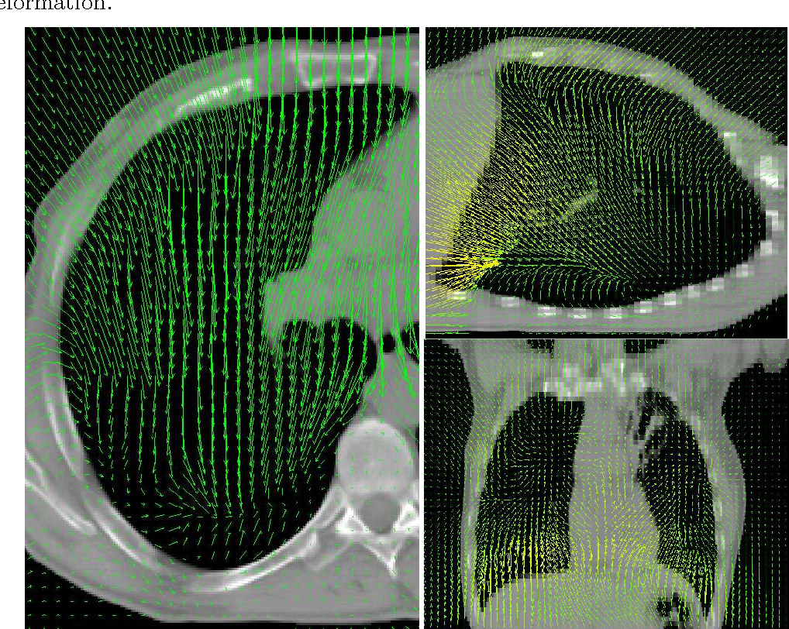[17] Figure IX: Deformable Image Registration Flow Field

Most of the time, medical image registration deals with registering two images, the source image or moving image, and the target image or fixed image, which are related by a transformation. The goal is to find a transformation that optimizes an energy function quantifying the alignment of the transformed source image and the target image through matching criterion or similarity metrics. A commonly used method for calculating the transformation matrix is the iterative closest point (ICP) algorithm that iterates to the nearest minimum of local error. There are many ways to classify different types of image registration including monomodal and multimodal image registration, where monomodal image registration compares two images of the same type of imaging modality and multimodal images registration compares across different imaging modalities. For monomodal image registration, there are pixel-based registration methods that use pixel intensities, gradients and features to determine the transform. For multimodal image registration, optimization of mutual information such as curvature are used to determine the transform which is much more computationally expensive. There exists 2D and 3D image registration based on the dimensions of the images and registration can be performed from 2D-2D, 3D-3D and 2D-3D. Image registration can also be classified as intrinsic or extrinsic based on how they extract feature points. Extrinsic registration relies on artificial fiduciary markers attached to the patient while intrinsic registration relies only on the patients’ natural anatomical features. Image registration can deal with two different types of transforms, rigid transforms and deformable transformations. Rigid transformations can be described by homogeneous transformation matrices while deformation transformations can be described by nonlinear models such as elastic body models, viscous fluidic flow models and diffeomorphism models. From new developments in deep learning, the deformation transformations can be learned with CNNs and the resulting optical flow fields can be visualized [18]. Machine learning has improved upon classical image registration methods by automatically selecting features to improve accuracy of image registration and improving the computing time to find the optimal transformation parameters.

2.5 Alternative Imaging and Registration Techniques

Some alternative imaging and registration techniques that do not necessarily lie in the classical image registration realm exist including optical flow methods and feature tracking methods.

Optical flow essentially describes the flow of image intensity between two images for every pixel between the two images. Optical flow is based on the brightness constancy assumption meaning the brightness of a certain point in the image will remain constant, I(x(t),y(t),t) = C. There are many ways to do optical flow including the classical methods like the Lucas-Kanade optical flow method and Horn-Schunck optical flow method which uses the optical flow equations and additional assumptions to calculate the flow. Modern methods include using CNNs to calculate optical flow. A major weakness of optical flow is that it is really hard to collect ground truth data. Synthetic datasets for optical flow in simulation like FlyingThings3D [63] exist that provide optical flow data for many different objects in many different scenarios. Ground truth data can be determined from these scenarios because everything is programmed in simulation including the exact positions of each object at each time as well as the exact intensity of each object.

Feature tracking is a widely studied and used method in computer vision to find feature correspondences between two images. One of the older methods of feature tracking include the Harris detector [64] which is a good detector for finding the corners in an image. Some of the newer methods of feature tracking include methods like SIFT, SURF, BRISK and ORB [65] which are optimized for speed and accuracy. Usually these feature detectors are used alongside outlier removal algorithms like RANSAC to remove feature correspondences that don’t seem to align with other similar feature correspondences. Feature detectors can also be used to find transformations between the points in two images. Feature tracking can be applied in a wide variety of different problems in computer vision and robotics like registration.

2.6 Levels of Autonomy for Surgical Robotics Systems

In recent years, there has been growing interest in moving towards greater autonomy for surgical robotics systems [19]. Yang et al. proposed six levels of autonomy for surgical robotics. Level 0: no autonomy, Level 1: robot assistance, where the system provides assistance to the surgeon and they have full control of the operation (da Vinci Robot system), Level 2: task autonomy, where the robot can perform certain tasks automatically and the surgeon has some control during the operation, Level 3: conditional autonomy, where the surgeon or robot can devise surgical strategies, but requires the surgeon to approve it and the robot performs the operation autonomously, Level 4: high autonomy, where the robot can make surgical decisions under a surgeons supervision and Level 5: full autonomy, where the robot can perform the whole surgery without human intervention. Currently there are developments toward achieving Levels 2 and 3 [19] of surgical automation that start to move away from teleoperation [9]. The different types of image-guided surgical robotics systems can be defined by their levels of automation. There are ones that execute predefined plans on preoperative medical images, ones that use real-time imaging data to update the 3D reconstruction of the world in software, and ones that require continuous operation by the user by examining augmented reality software.

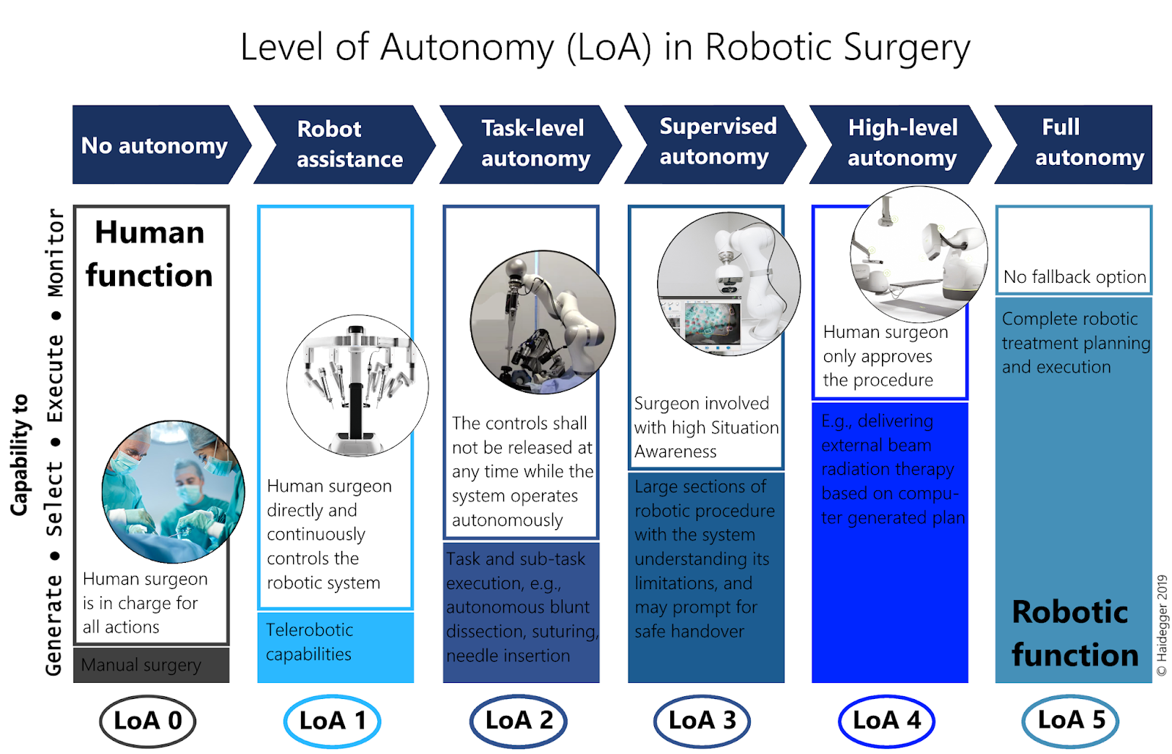

[20] Figure X: Levels of Autonomy in Robotic Surgery

2.7 Vision in Image-Guided Surgical Robotic Systems

Over the past two decades, there have been great improvements in image-guided robotics due to the advancements made in the machine learning and computer vision fields. Machine learning methods are used for surgical tool tracking and pose estimation to better determine their positions and orientations in real time. Simultaneous localization and mapping (SLAM) based methods can be used to track the position and orientation of endoscopic cameras inside the patient’s body, and update the 3D reconstruction of the body cavity as the cameras explore inside the body. Visual servoing can be applied with endoscopic cameras and extrinsic fiducials to control the movement of robot manipulators and surgical tools [21][22]. Visual servoing is a control technique used by robotic manipulators mounted with a camera that moves depending on how far specific landmarks in the image are from a desired location. Many of these tasks are made more difficult due to the deformation of tissues inside the body.

Image-guided robotics systems often use endoscopes and stereoscopic cameras to help with navigation, tracking of surgical tools, and the reconstruction of the 3D map of the world. For surgical tool tracking, cameras can use neural networks for object detection or extrinsic registration methods like adding fiducials. An endoscope is a small camera attached to an extendable tube that can explore inside the body through a small cavity. Often the tube is flexible but it can be rigid as well. Due to the flexibility of the tube, it is difficult to know the camera’s exact location without examining the camera feed and triangulating its position from known fiducial markers in the image. The tube can only be modeled with a deformable transformation and cannot be modeled by rigid transformations. The method of finding the position and orientation or pose of the camera is called camera pose estimation which is a key concept in vision based tracking. Camera pose estimation aims to find a camera calibration matrix that relates world coordinates to image coordinates based on an assumed model of the camera. If the pose of the camera is known, the problem can be done in reverse to determine the world coordinates of unknown landmarks in the image. The camera calibration matrix is made up of the product of the camera intrinsic and extrinsic matrices. The extrinsics contain the pose of the camera which needs to be solved for. Often the camera intrinsic matrix is known and can be found through a process called camera calibration which optimizes the parameters using multiple views of a known structure like a checkerboard pattern. The extrinsics can then be solved using the location of known feature points[22]. Sometimes it is necessary to determine the transformation between multiple camera views which is called multiple view geometry. The endoscope is often a monocular or singular camera which cannot communicate depth information through imaging without using multiple views, however stereoscopic endoscopes are an emerging technology.

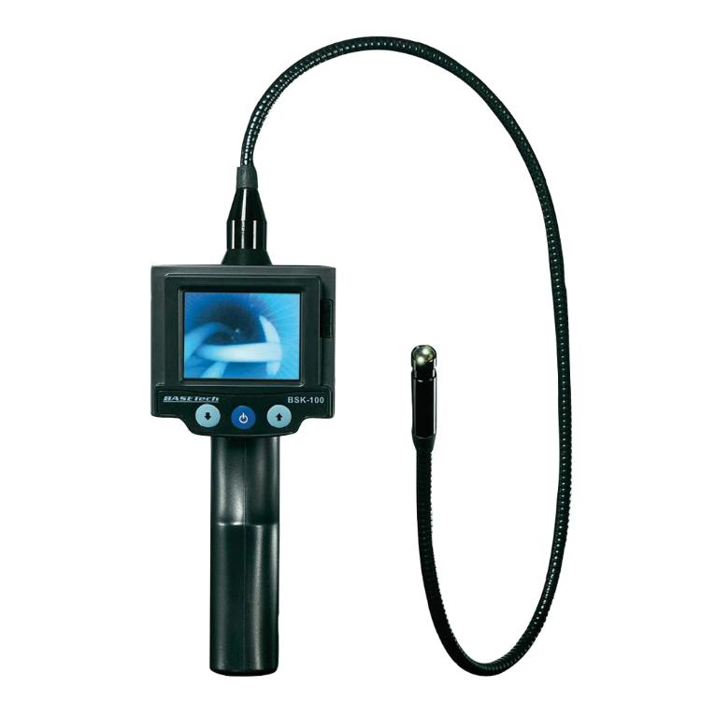[23]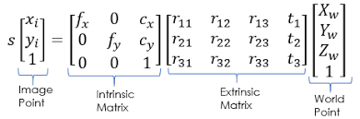

Figure XI: An Endoscope Equation I: Camera Equation for Camera Pose Estimation 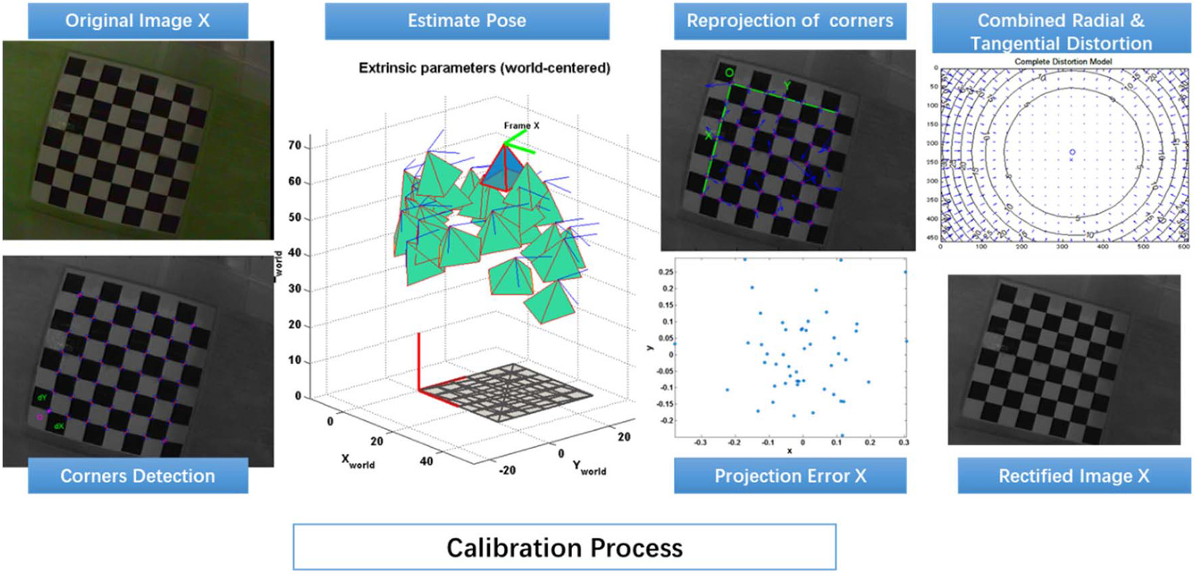[22] Figure XII: Steps for Camera Calibration

Stereoscopic cameras address the problem of the lack of depth information for monocular cameras. A stereoscopic camera consists of two fronto-parallel monocular cameras a fixed baseline distance apart. The camera uses image disparity as a way to recover depth information. Disparity is the difference in pixels of the location of a particular landmark between the left and right images. Due to epipolar geometry and triangulation, disparity is inversely proportional to depth of the landmark.Stereovision classically involves 4 steps, lens undistortion, stereo rectification, correspondence and reprojection through triangulation. Now there are machine learning models that can learn depth from stereo images and output much more accurate depth maps than classical models. Stereoscopic imaging has great influence on vision-based tracking and surgical navigation. It can also be used for developing a 3D reconstruction of the world for image-guided surgical robotics[22].

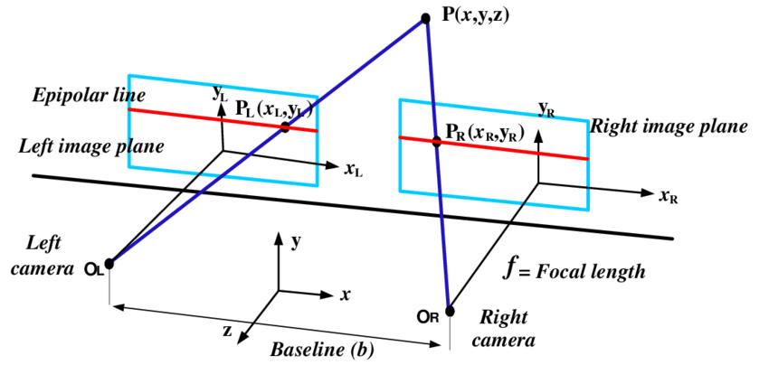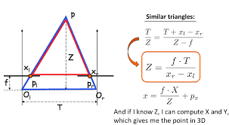[24] Figure XIII: Epipolar Geometry for a Stereo Camera Equation II: Disparity Equation

2.8 Project Introduction

The image-guided surgery system designed for the thesis project is based upon the Franka Emika Panda collaborative robot. Overall, there have not been many image-guided surgical robotics systems that use collaborative robots. There are some instances where KUKA robots were used for image-guided intervention applications [25] [26] but there aren’t many instances where Franka Emika Panda collaborative robots were used. The image-guided surgical robotics system used for the project will operate on preoperative images but will also incorporate a real-time update of the images to update the reconstruction of the model. There is no access to medical imaging technology like CT-scanners, MRIs and ultrasounds so the imaging will be replaced with a camera connected to a Raspberry Pi 4 Model B computer so a reconstruction of the scene can be viewed. Originally the plan was to create a 3D reconstruction of the model in 3D Slicer, but after some further investigation into the problem, we felt that it was too complicated and unnecessary to create a 3D reconstruction in the short time frame we had to do this project. However, creating a 2D reconstruction instead may be worthwhile. Additionally, the scene we are planning on testing on did not really need 3D reconstruction since it is a flat surface so a 2D reconstruction would probably work better. Instead of using a 3D model to operate on, we would use a 2D image instead. The possible cameras to consider being used for the application included a USB stereo camera, the OAK-D Lite camera and a cheaper Raspberry Pi Camera V2 based with the Sony IMX219 8-megapixel sensor. In comparison to other stereo cameras like the RealSense, the OAK-D Lite camera is compatible with the DepthAI platform [27] adding many on-device features (AI modes, tracking, scripting etc.) and can be used in embedded applications. RealSense cameras are also winding down and are out of stock so the OAK-D Lite camera is more geared towards future use [28]. The Raspberry Pi Camera V2 is a monocular camera with great resolution. However, the lens is not as large or good as some similar cameras, but we felt that it was unnecessary since we would only be using the camera at short distances.

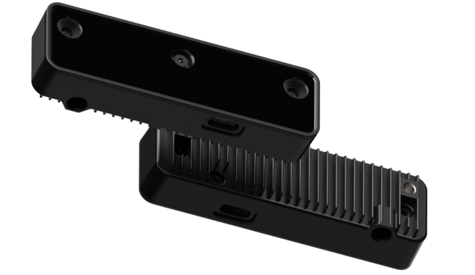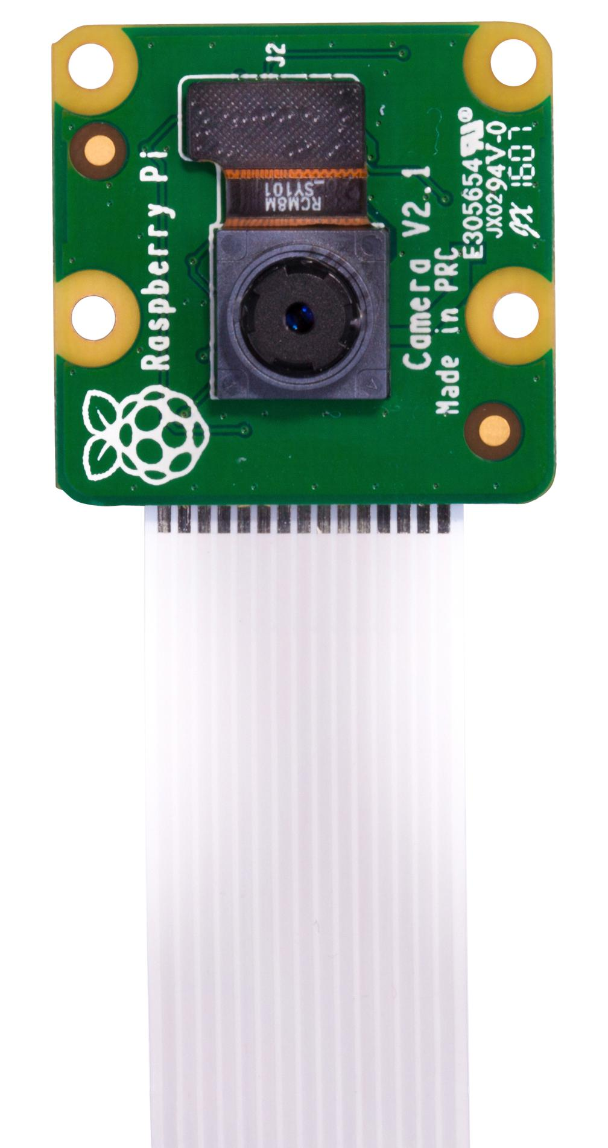[29] [66] Figure XIV: OAK-D Lite Stereo Camera and Raspberry Pi Camera V2

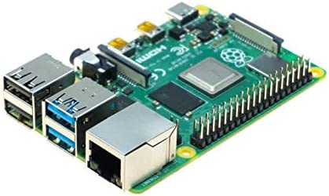[30] Figure XV: Raspberry Pi 4 Model B

|  |  |
| --- | --- |
| Robot | Franka Emika Panda |
| Camera | Raspberry Pi Camera V2 or OAK-D Lite |
| Computer | Raspberry Pi 4 Model B |
| Desktop Computer | Ubuntu 20.04 |

Table I: Hardware for Image-Guided Surgical Robotics Setup

The medical imaging software used for the image-guided surgical robotics system is 3D Slicer, a popular open-source medical imaging software. The software can be built from source code which can be modified and new extensions to the software can be created. There are 3D Slicer programming libraries that can help with creating extensions which can be programmed using Python or C++. Communities exist that are dedicated to creating 3D Slicer extensions. The software also has a useful Python interface that can be used while using the software and manipulating image data. One issue with 3D Slicer and other medical imaging software is that it is difficult to integrate with ROS and ROS2. The difficulty of ROS integration may explain the low number of collaborative robots used for image-guided surgical robotics applications. Fortunately over the past few years, solutions for 3D Slicer and ROS2 integration have been found.

2.9 ROS and 3D Slicer Integration

The ROS-IGTL-Bridge is a ROS node that establishes a TCP/IP connection with 3D Slicer and shares data using the open network communication protocol OpenIGTLink. The ROS-IGTL-Bridge can be subscribed to other topics in the ROS network and when it receives a ROS message, the node translates the ROS message to an OpenIGTLink message and sends it to external software through the TCP/IP connection. The node can also receive OpenIGTLink messages, translate them to ROS messages and publish the ROS messages in the ROS network [7]. Typically many medical imaging devices, cameras, sensors and computers for image-guided therapy use OpenIGTLink as a communication protocol for communication. OpenIGTLink is even supported by a few commercial device manufacturers [31]. However, since medical imaging devices are not used for this project, OpenIGTLink is not useful for this application. In July 2022, a paper called “Bridging 3D Slicer and ROS2 for Image-Guided Robotic Interventions” [1] was published and they devised a solution that made 3D Slicer a ROS node directly in a custom 3D Slicer extension called the Slicer-ROS2-Module. That way 3D Slicer could subscribe and publish to ROS topics directly without using a bridge. Another feature of the Slicer-ROS2-Module was that it could display a model of a robot directly in 3D Slicer and compute the robot’s forward kinematics based on a joint state publisher, URDF file and STL file of a robot. They provided their code in an open source Github repository [32]. The thesis project used some of the code for the Slicer-ROS2-Module as a base and built upon it to create a new 3D Slicer extension with extended functionality for image-guided surgical robotics. ROS2 was used for the project instead of ROS1 since ROS1 is being phased out in around a year, making the project more useful for future use and because the Slicer-ROS2-Module is already compatible with ROS2.

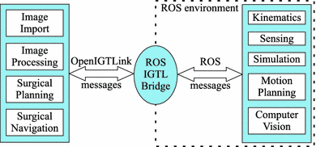 [7]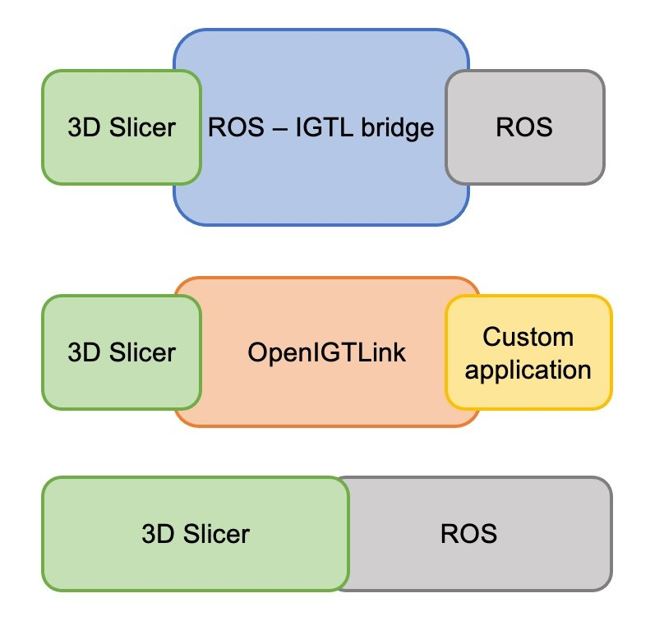[1]

Figure XVI: ROS-IGTL-Bridge Setup Figure XVII: Slicer-ROS2-Module Setup

Comparison

2.10 Image-Guided Robotics System Final Test and Evaluation

The scene to be tested on for the final evaluation of the image-guided robotics system will be on a deformable MRI scan image of a brain printed on fabric. The robot should be able to move their end effector to the desired location while the fabric is unstretched and undisplaced and while being stretched and displaced after performing a registration. After seeing the image of the unstretched material in 3D Slicer, the user should map out the trajectory using fiducial markups. For the first test, do not stretch out the material and see how close the end effector gets to the desired location. For the second test, get an initial fixed image of the unstretched material. Then stretch and displace the material, get the moving image, and perform the registration to predict where the new desired location is. See how close the end effector gets to the new desired location.

|  |  |  |
| --- | --- | --- |
| **Autonomy Level:** | Level 0/1 | Level 2/3 |
|  | No | Yes |
| **Operation:** | Pre-operative | Intraoperative |
|  | Yes | Yes |
| **Surgery Type:** | Teleoperation | Pre-operative Planning |
|  | No | Yes |
| **Camera Type:** | Endoscopic | Stereoscopic |
|  | No | Yes |
| **Registration Mode:** | Monomodal | Multimodal |
|  | Yes | No |
| **Registration Type:** | Pixel Intensity Based | Mutual Information |
|  | Yes | No |
| **Registration Dimensions:** | 2D - 2D | 3D - 3D / 2D - 3D |
|  | Yes | No |
| **Registration Feature Extraction:** | Extrinsic | Intrinsic |
|  | Yes | Yes |
| **Registration Transformations:** | Rigid | Deformable |
|  | Yes | Yes |
| **Registration Method:** | Classic | Machine Learning |
|  | Yes | Yes |

Table II: Image-Guided Surgical Robotics Thesis Project Details

**3 Methods and Findings**

3.1 Franka Emika Panda Robot Testing

First, the Franka Emika Panda robot was tested with the Franka Control Interface (FCI) off and connecting it to a desktop computer running Ubuntu 20.04 [33]. A network connection was established between the computer and the Franka robot. All the drag and drop commands were tested on the robot completing simple trajectories. The robot’s locking and unlocking mechanism for the end effector was tested and if the end effector could be moved manually when the locking mechanism was off. Software repositories like ROS2, franka_ros2[34] and libfranka[35] were downloaded to the desktop computer. The ROS2 Foxy distribution[36] was used because the franka_ros2 library needed that distribution. Libfranka is a C++ library for providing low level control of the Franka Emika research robot and franka_ros2 is a library and package providing ROS2 integration with the Franka robot. These repositories allowed testing of the robot with the FCI on. By using the FCI, it allowed a fast and bidirectional connection with the robot arm and allowed sending of real time control values at 1 kHz using ROS. Commands that could be sent included gravity compensated joint level torque commands, joint position or velocity commands, and cartesian pose and velocity commands. At the same time 1 kHz of measurement data was sent back to the robot including measured joint data such as position, velocity and torque data, estimation of externally applied forces and torques, and collision information. All the tests under the franka_ros2 library were run to make sure the robot worked accordingly, including the MoveIt example, the RViz simulation, the example controllers (Move-to-start, Gravity Compensation) and the launch file commands. Unfortunately, franka_ros2 only had a reduced number of controllers and controller interfaces including joint positions, joint velocities and measured torques. Franka_ros2 also did not have access to kinematic or dynamic quantities so forward and inverse kinematics was not easily performed. In order to control the end effector position and joint state, a new controller would have to be programmed or an existing controller from another source would have to be used [33].

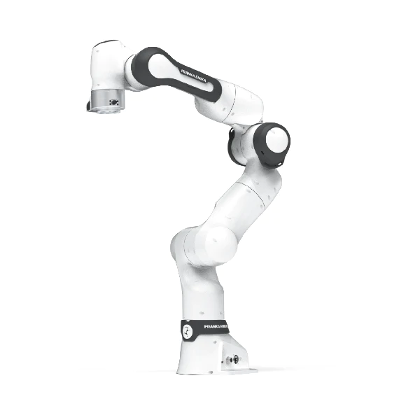[37] Figure XVIII: Franka Emika Panda Robot

3.2 Control of Franka Emika Panda Robot

There were a couple possible alternatives of controllers to control the robot. Programming a new controller did not seem feasible due to time constraints and inexperience with programming a new controller. There were also safety concerns with creating a faulty controller that could cause injury or damage to the robot. There was an existing controller that worked in ROS1 programmed by Radian Gondokaryono and Raghav Srinivasan, members of the MEDCVR lab. The controller would have to be rewritten using ROS2. However, there were very specific tolerances for commands to the controller and the controller only dealt with joint positions, not coordinates, making it difficult to use for this thesis project. There was a Github repository [38] called ros2_controllers that provided generic ROS2 controllers but it was not clear how it would interface with the Franka robot. Also, since the controllers did not work with a specific robot there was an issue with calculating the forward and inverse kinematics to know what coordinates a joint state corresponded to and what joint state could achieve a particular end effector location in coordinates. Luckily, the MoveIt2 library [39] and package provided a solution. MoveIt2 is the robotics manipulation platform for ROS2 allowing for motion planning, manipulation, kinematics, control and navigation. The MoveIt2 library provided an easy to use Move Group C++ Interface that allowed control of the Franka robot with a C++ program using minimal code. The robot could be controlled by directly providing coordinates or joint positions for the robot to travel to. The library was compatible with the Franka robot directly by specifying the “panda_arm” as the desired move group. The controller and inverse kinematics did not appear directly in the code so they were not something that the programmer had to be worried about. MoveIt2 also allows for easy visualization of the robot and motion plan in RViz [40].

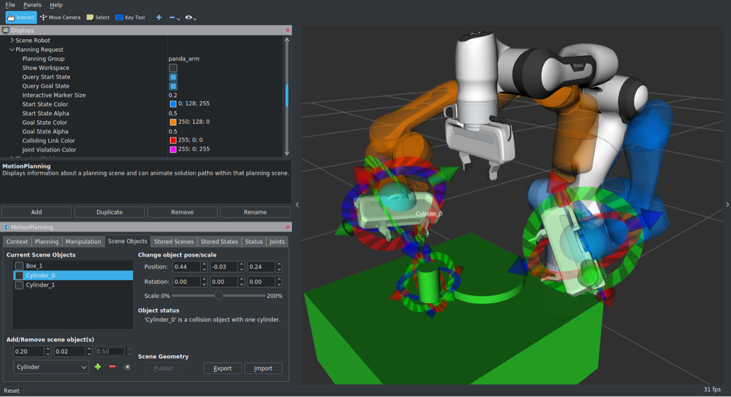

[41] Figure XIX: MoveIt2 Motion Plan Simulation of Franka Emika Panda Robot

3.3 3D Slicer Markup Path Python Extension

After successfully testing the robot, 3D Slicer was tested. Initially the plan was to replicate the work done in the “Bridging 3D Slicer and ROS2 for Image-Guided Robotic Interventions” paper by creating a Python extension that made 3D Slicer a ROS node and using 3D Slicer’s Python interactor. However, it was found that the version of Python in 3D Slicer was an earlier version that did not support rclpy [42], a library required to program in the Python version of ROS2 after talking to one of the developers of the Slicer-ROS2-Module, Laura Connolly. The issue was not identified until after creating a Python extension in 3D Slicer that calculated the coordinates of a path traced out by a Markup within 3D Slicer segmented by a specific distance. The Markups the extension supported in marking out paths were Curves, Closed Curves, Fiducials, Lines, Angles and Planes. The extension allowed the user to select the Markup to segment and calculate the coordinates of the path with a QT user interface. The coordinates of the resulting trajectory were printed out in the Python interactor console. Although the Python extension would not be part of the final project, it was still a contribution to the 3D Slicer extension community and provided experience with creating extensions and using the programming libraries 3D Slicer used including VTK [43], QT [44], and Slicer [45] libraries.

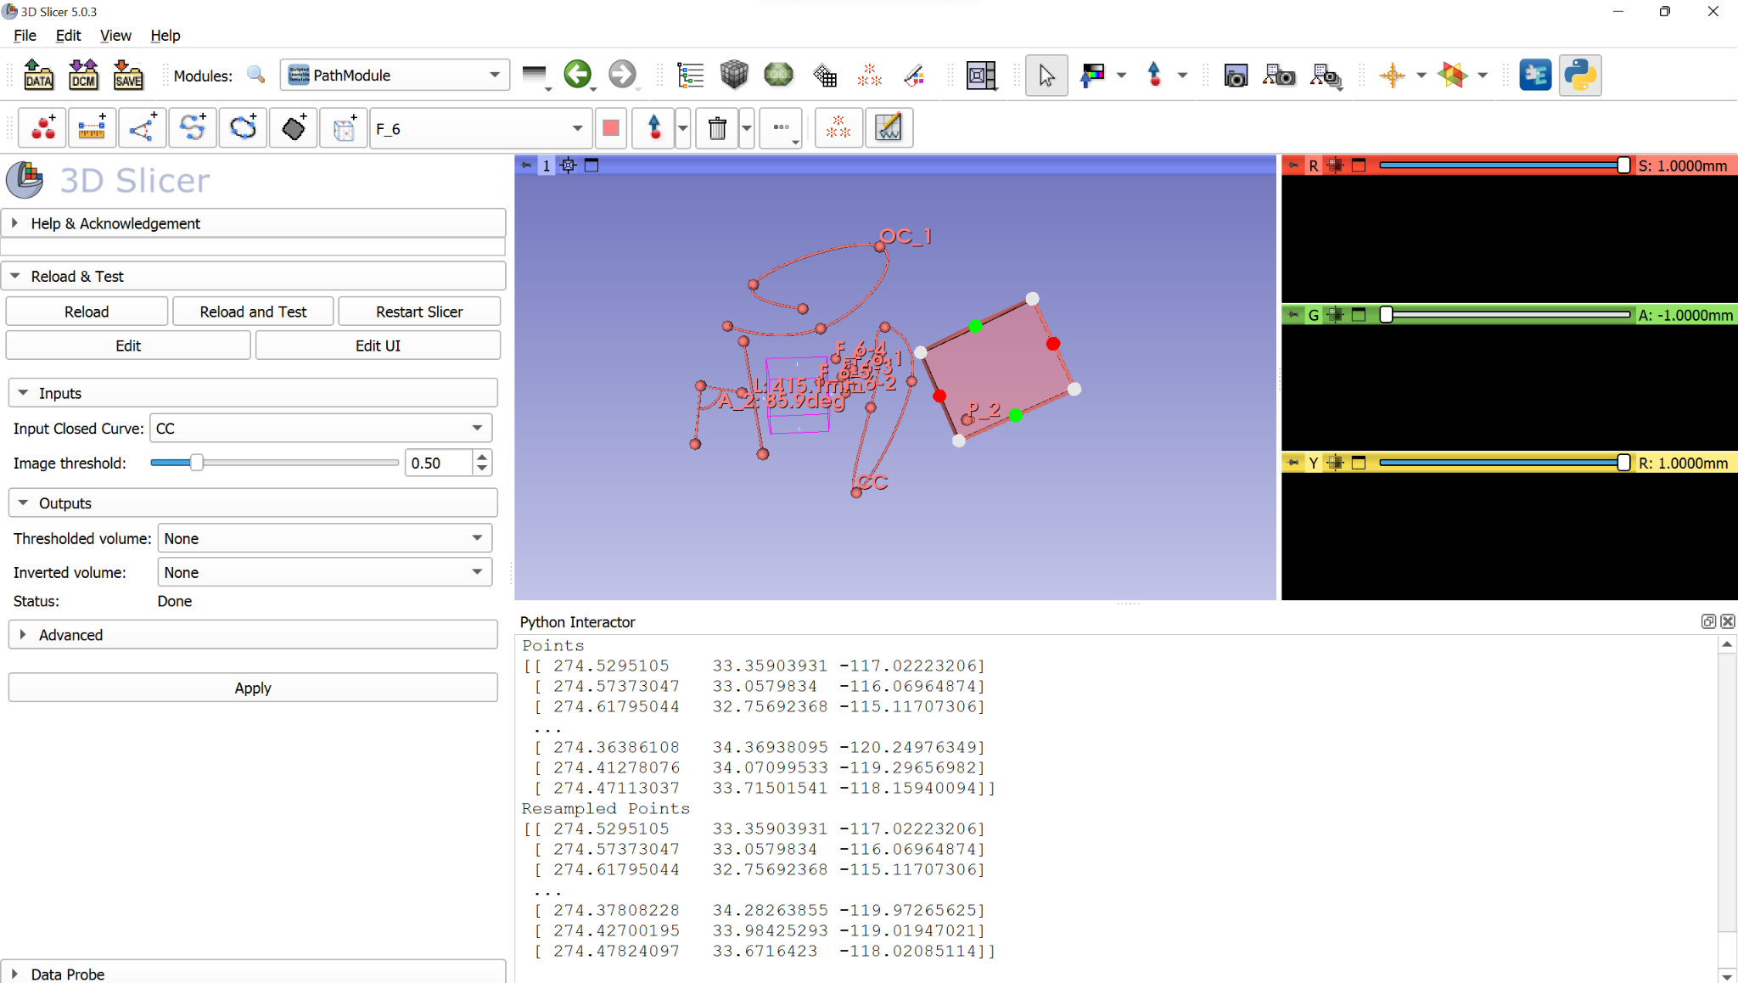

Figure XX: 3D Slicer Extension to Select Markup and Output Path

3.4 Exploration of Slicer-ROS2-Module with Sensable Phantom Omni Robot

The Slicer-ROS2-Module was explored further after finding out 3D Slicer’s incompatibility with rclpy. The code from the Github repository was tested on a Sensable Phantom Omni/Geomagic 3DS Touch robot [47] from the Continuum Robotics Laboratory. The Slicer-ROS2-Module also required a joint state publisher, a URDF and STL files of the robot to run properly which was provided by another Github repository [48]. The code required 3D Slicer to be built from source [49] which took some time but eventually the code was able to run and display the robot in 3D Slicer. The code was tested with a pretend joint state publisher which was a ROS node publishing to the topic that the actual robot is supposed to publish to. The Phantom Omni robot in 3D Slicer moved according to the joint commands sent by the pretend joint state publisher. The code was also tested with the real Phantom Omni robot and the robot in 3D Slicer was able to move according to the movements of the real Phantom Omni robot.

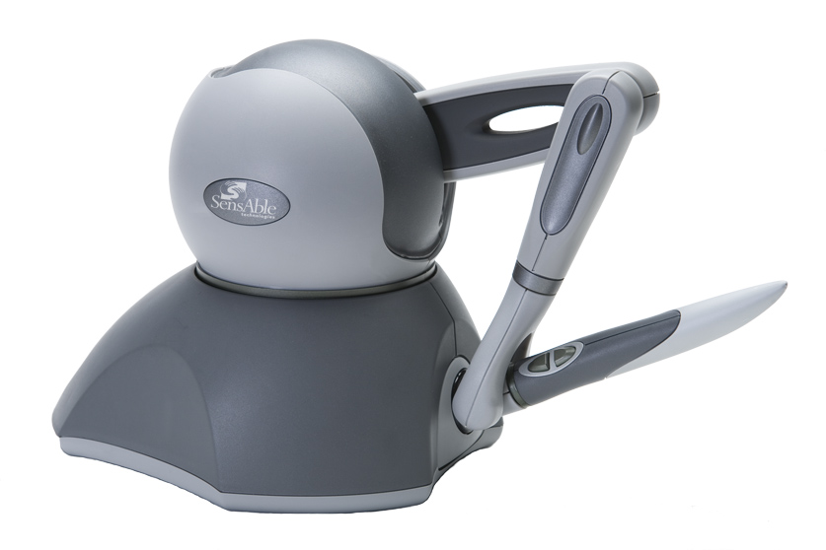[50] 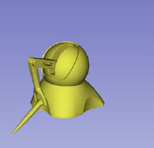

Figure XXI: Sensable Phantom Omni Robot Figure XXII: Phantom Omni in 3D Slicer

3.5 Exploration of Slicer-ROS2-Module with Panda Robot

After testing the Slicer-ROS2-Module on the Phantom Omni, the code was ready to be tested on the Franka robot. The URDF and DAE files of the Franka robot were found in the franka_description folder of the franka_ros2 Github repository [51]. Since the Slicer-ROS2-Module was not compatible with DAE files, the files were converted to STL files with a DAE to STL converter [52]. A new pretend joint state publisher was programmed using Python for the Franka robot. The URDF, DAE files, pretend joint state publisher and a launch file for it were added to a new package. Using the new package and pretend joint state publisher, the Slicer-ROS2-Module was tested and successfully displayed the moving Franka robot in 3D Slicer. The code still needs to be tested using the real Franka robot.

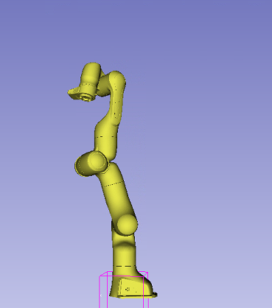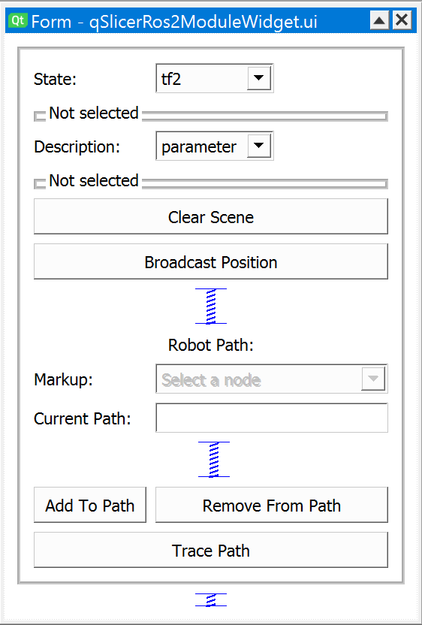

Figure XXIII: Franka Robot in 3D Slicer Figure XXIV: Updated Qt UI

3.6 Broadcasting the Robot State of the Panda Robot Using Franka_ROS2 Controllers

Broadcasting the robot state of the Franka Emika Panda Robot in 3D Slicer was tested on a variety of different controllers provided by the franka_ros2 library. The library includes a variety of controllers including Move_To_Start, Joint_Impedance, Gravity_Compensation, and a MoveIt controller. The Move_To_Start controller is pretty self explanatory. The controller just moves the robot to its home position. The Joint_Impedance controller moves the end effector arm back and forth in a periodic motion. The Gravity_Compensation controller is useful and interesting. The controller provides just enough torque to support the robot’s own weight so all the robot links can be moved around by physically moving the robot while the controller is on. The robot can normally be moved this way if the light on the bottom of the robot is white, or it is not in the ready position and the buttons on the robot end effector are pressed. By running the controller, the robot can be in the ready to run program state and you are still able to move the robot manually. The MoveIt controller allows planning and executing of trajectories in RViz when motion planning was activated, which showed both a model of a robot and a hologram of the desired goal position of the robot. By dragging the position of the end effector to a desired goal position, the hologram of the desired goal position of the robot would move with it. When satisfied, the plan and execute button on the interface in RViz could be pressed and the robot would plan and execute the trajectory in the real world. All the controllers seemed to update the robot state in 3D Slicer according to where the robot moved, indicating that the broadcasting works in a lot of cases. Another conclusion that came from this test was that the broadcaster should theoretically work when using custom MoveIt commands to the robot since it was working when tested using the MoveIt controller.

3.7 Software Implementation of a Raspberry Pi Camera V2

The Raspberry Pi camera V2 was chosen for imaging and image registration because it allows us to take single frame images of various sizes with OpenCV. The single frame images were sufficient, because we felt that our experimental setup did not require depth information. In the case that a model object was being operated on, a depth camera broadcasting a point cloud to 3D Slicer would be useful for image-guided surgical robotics. In hindsight, perhaps using a more expensive camera like the OAK-1 USB camera would be better suited for the imaging without the need for middleware like the Raspberry Pi. The Raspberry Pi does provide some advantages however. The camera simulates the modularity of a practical surgical robotics setup including using medical imaging devices such as an MRI which communicates to a central computer with serial communication. Wireless communication is also possible with the Raspberry Pi.

On the Raspberry Pi, we download the desktop version of Ubuntu 22.04 which is one of only versions of Ubuntu Desktop available to flash onto an SD card. The reason we use Ubuntu desktop is because it makes things a lot easier to debug and allows you to connect to the internet. We use ROS2 Foxy due to the franka_ros2 repository using ROS2 Foxy which is not compatible with Ubuntu 22.04. However, we can get around this issue by using a Docker container containing ROS2 Foxy for Ubuntu 22.04 which is available online[67]. We could use a different ROS2 distribution like ROS2 Humble that is compatible with Ubuntu 22.04, but it is generally bad practice to publish and subscribe to two different ROS distributions and it is not guaranteed to work. We create a Docker container that has the same IP address as the Raspberry Pi to ensure it is able to communicate with the I/O device, the Raspberry Pi Camera V2 in our case. We also download the raspi-config package on the Raspberry Pi to enable communication with the camera.

In the Docker container we create a simple ROS node that sets the resolution of the Raspberry Pi camera, takes images and turns them into grayscale images using OpenCV. Grayscale images work better for image registration in VoxelMorph, since VoxelMorph was originally developed for image registration on medical imaging data which are grayscale images. The ROS node then publishes the images through a ROS publisher and to the desktop computer. ROS uses an encoded image ROS message to communicate image data. We use another library called cv_bridge to convert from an OpenCV image to an encoded image ROS message and to convert from an encoded image ROS message to an OpenCV image. We decided to connect the Raspberry Pi to the desktop computer via ethernet cable just to make sure we have a stable connection and streaming of data. We mount the Raspberry Pi and the Raspberry Pi Camera V2 upside down on a frame so it can see the operating surface. On the operating surface, we have an image printed on stretchy fabric to simulate deformable image transforms, by pulling on different sides of the fabric to stretch the image in different directions.

3.8 Adding the Raspberry Pi Camera V2 to the Environment

The frame holding the camera is made of two T-frames which makes it easy to mount the Raspberry Pi and Raspberry Pi Camera V2 using screws and T-frame nuts. The operating surface is an optical table with M6 screw holes so the T-frame could be attached to the surface using an L-bracket. The Raspberry Pi needed a separate mount because the Raspberry Pi has really small mounting holes that could not be mounted on the T-frame directly. We use a 3D printed CAD model of a Raspberry Pi mount[68] found online to mount the Raspberry Pi and then attach the mount with the Raspberry Pi to the T-frame using T-frame screws. The mounting holes had to be drilled slightly larger to fit the M6 screws that attach to the T-frame. The Raspberry Pi camera V2 is attached to the Raspberry Pi via a ribbon cable. We have a premade case for the Raspberry Pi camera from Adafruit[69], that we use to enclose the Raspberry Pi camera to protect the camera as well as hold it in place. On the back of the camera case, there is a thread that fits M6 screws so we were able to attach a M6 T-frame screw to it and mount the camera on the T-frame. We noticed that the T-frame screw is slightly loose and since the I/O port for the ribbon cable is offset from the center, the ribbon cable tends to offset the camera so it is tilted at an angle. The camera is just able to capture the surface of the whole optical table. Most of the building materials were purchased at McMaster Carr[70].

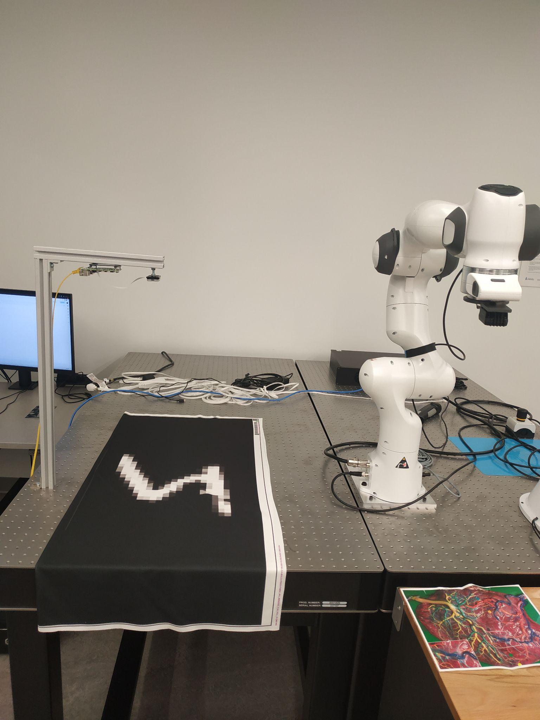

Figure XXV: Experimental Setup with Raspberry Pi Camera V2

3.9 Image Registration using VoxelMorph

We used a Python machine learning library called VoxelMorph to perform image registration. VoxelMorph[71] is a convolutional neural network or CNN based on the UNet architecture. The inputs to the network are the moving and fixed images and the outputs for the network are the resulting moved image and the deformation field. The deformation field is a field of vectors for each pixel of the image. The vector shows where a particular pixel has moved from the fixed image to the moving image in both the x and y directions of the image. For our particular task, we used VoxelMorph to calculate where a particular point in the image has traveled. The reason we chose to use VoxelMorph, a convolutional neural network to perform image registration is because image registration and deformable transformations are very difficult to find analytically and the transformation function between the moving and fixed images may be impossible to solve otherwise.

A majority of existing deformable registration algorithms iteratively optimize the transformation by minimizing an energy function. The optimization problem can be described as follows:

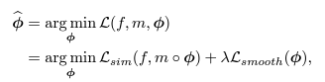

Equation 3

where f is the fixed image and m is the moving image and $ϕ$ is the transformation function that maps f to m. m $∘ϕ$ represents the m being warped by $ϕ$ which gives the resulting moved image. The function Lsim is the similarity function between the two inputs, which can include intensity mean squared error, mutual information or cross-correlation. The function Lsmooth adds regularization to the problem and $λ$ is the regularization parameter. $ϕ$ is often represented by a displacement vector field **u** which shows the vector offset for each pixel in the image and $ϕ$ can be described as $ϕ$ = **I** + **u** where **I** is the identity transformation. Diffeomorphic transforms represent $ϕ$ as an integral of a velocity vector field which allows for invertibility of the transformation.

Most traditional algorithms specifically optimize for each pair of images which may be expensive for registering many images together. Voxelmorph assumes the field can be computed by a parameterized function of the data. The function parameters are optimized by minimizing the energy over a whole dataset of images. Voxelmorph replaces pair-specific optimization of the deformation field with global optimization of the field over parameters. Voxelmorph is also capable of velocity based representations, but we use the displacement field representation due the clarity of the transformation and the ability to implement into the problem being solved. The displacement vector field model is also better documented for use in other capacities [71].

The VoxelMorph architecture used for the project is based very similarly to the implementation in the original VoxelMorph paper[71]. VoxelMorph works in any n-dimensional spatial domain $Ω$. However instead of using a 3-dimensional spatial domain like in the paper, we use a 2-dimensional spatial domain for our problem. Despite having a colour camera, we convert to grayscale images because VoxelMorph has been more thoroughly tested with grayscale images even though it can work with color images as well by changing the number of channels. In the end, we take pictures of black and white fabric anyway so using RGB images do not make too much of a difference. The convolutional neural network models a function g $θ$ (f, m) = **u,** where $θ$ are the parameters of the network which are the kernels of the convolutional layers. A 3-dimensional image stores the displacement field **u** between f and m where each voxel **p** is a displacement such that such that [m](**p**) is similar to f(**p**). The network is shown in the figure below where it takes in the images f and m as input and computes the registration field $ϕ$ using the parameters $θ$. A spatial transformation function is used to transform m to the moved image m $∘ϕ$, allowing for the evaluation of the similarity between m $∘ϕ$ and f. A registration field is obtained by evaluating the function g $θ$ (f, m) on unseen images f and m when registration is performed. Stochastic gradient descent is used to find the optimal parameters by minimizing a loss function over a training set.

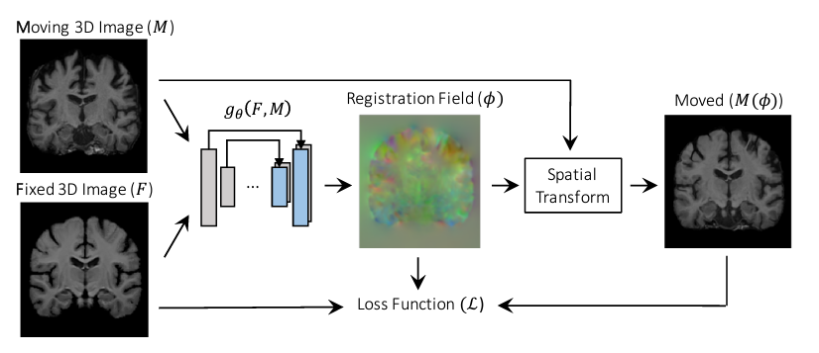

Figure XXVI: VoxelMorph Model Architecture

The Voxelmorph architecture we use for this project is a convolutional neural network structure similar to UNet, consisting of an encoder and a decoder with skip connections which is depicted in the figure below. The network takes in a single input concatenating m and f into a 2-channel 2D image. 2D convolutions are applied during the encoding and decoding stages with a kernel size of 3 and a stride of 2, followed by a LeakyReLU layer with a parameter of 0.2. The convolutional layers are able to capture the hierarchical features that exist between the moving and fixed images which is used to determine $ϕ$. The strided convolutions of the encoder reduce the size of the image as shown by the numbers in the figure below. Due to the reduction of the image size to 1/16 the original size for Voxelmorph architecture we use, we choose the dimensions of the image we use based on that. Since the Raspberry Pi Camera V2 can take images of any size up to 3280x2464 and with a minimum size of 64x64, we can select the dimension of the images we want. Initially an image size of 2560x1440 pixels was chosen to be used since it is a common image size used for the Raspberry Pi Camera V2. The image size satisfied the dimensionality requirement for the UNet architecture, since we need to make sure that after reducing the image size to 1/16 of the original size, the number of pixels in both the x and y directions of the image are an integer number. 2560x1440 is equivalent to (5*2^9 x 45*2^5) so after reducing the image size to 1/16 the original size, the new size would be (160x90). However, after testing we found that the resolution of the image was way too high for the desktop computer’s RAM to handle. The image size was reduced by a factor of 10 for each dimension so the new image size would be (256x144) making the image (2^8 x 9x2^4). In order to add a small factor of safety, we round the y dimension of the image to 160 pixels which is a better number to work with, making the final image size (256x160) or (2^8 x 5x2^5). It is possible to add padding to the image in software, but we decided that it was better just to increase the size of the image taken.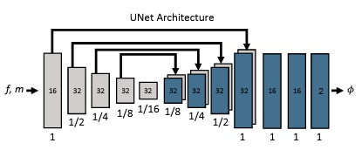

Figure XXVII: VoxelMorph Architecture Based on UNet Layers

The spatial transformation function works by computing a sub voxel location **p’** = **p** + **u**(**p**), where **u** is the displacement vector at a particular pixel **p** and linearly interpolating the intensity values at the eight neighboring voxels of **p’** because pixel values are only defined at integer locations. Since the gradients can be calculated, errors can be backpropagrated during optimization. The loss consists of two components, Lsim which penalizes difference in appearance, and Lsmooth which penalizes local spatial variations in $ϕ$. The loss function used combines mean squared error and L2 regularization over a hyperparameter $λ$.

The mean squared error function can also be called the mean squared voxelwise difference when f and m have similar image intensity distributions. The loss function equation can be seen below, where $Ω$ indicates a sum over all space the images take up and $\left|Ω\right|$ indicates the number of voxels each image takes up.

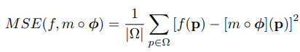

Equation 4

The L2 regularizer error function can be seen below. Minimizing the regularizer error function encourages a smooth displacement field $ϕ$ and penalize non-smooth $ϕ$ that is not physically realistic.

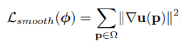

Equation 5

In order to simulate deformations in a 2D image, we print an image of an MRI scan of the human brain on stretchy and opaque fabric. In order to test the image registration on a simpler task first, we also printed an MNIST[72] image of the number 5 on the fabric.

3.10 Training Data Collection and Image Registration Pre-training

The training data was collected by collecting images from the Raspberry Pi camera V2, publishing to the image registration node, converting the images to grayscale and writing the images to a folder on the desktop computer. Around 1000 images were collected, 976 images to be exact, and split into 70% training data, 20% validation data, and 10% test or hold-out data. The images were collected over an 8 minute interval where the fabric was both displaced and deformed. The data collection was done for both the MNIST image and the brain MRI scan resulting in two data sets of 976 images. The image registration pretraining was performed in Google Colab. The images were compressed into zip files that could be loaded into Google Colab and unzipped.

The code is similar to the code presented in the VoxelMorph Introductory Tutorial linked on the VoxelMorph repository Github[73] which is written in Python and uses TensorFlow as the machine learning library, and the initial setup of the model is the same code as in the image registration node which you will see later. First the images are preprocessed by normalizing them between values of 0 and 1, which is a common practice in machine learning that produces better results. We use the VxmDense class in VoxelMorph to build the VoxelMorph CNN model directly as described in the previous section without needing to code the specific layers of the network directly. The only inputs the model needs is the size of the image and the UNet features of the encoder and decoder layers. The encoder and decoder features are the same as the UNet model in the VoxelMorph introductory tutorial and in the image above. The encoder features are 32, 32, 32, and 32 in order and the decoder features are 32, 32, 32, 32, 32, and 16. The features represent the sizes of the convolutional layers within the UNet architecture. Next we specify the parameters of the network, including the two custom loss classes they use which are the MSE loss and the L2 loss mentioned in the previous section. The weights of each of the loss classes are also specified with a constant weight of 1 for the MSE loss and a tunable hyperparameter lambda_param for the weight of the L2 loss function. We use a weight of 0.01 for the lamda_param for the brain MRI and a weight of 0.05 for the lambda_param for the MNIST digit. We also use the Adam optimizer with a tunable learning rate of 0.001 for both problems. Next there is a vxm_data_generator function that generates data to be input into the VoxelMorph model. The function is based on the generator object in Python which outputs data from a dataset of a specific batch size every time you iterate over the generator. The generator is useful for pre-training but it is not implemented in the image registration node later on where the preprocessing of the data for the model is done without the generator. We use a generator with a batch size of 32 for training, which is another tunable hyperparameter. Next, the number of epochs the model trains for and the number of steps_per_epoch are listed which are also tunable. Finally the model starts training by using the fit_generator function which takes in a generator, number of epochs and steps_per_epoch. We use 30 epochs and 15 steps per epoch for the MNIST digit and 200 epochs and 30 steps per epoch for the brain MRI. After training, the model weights are saved in a .h5 file to be loaded into the exact model for the image registration node as will be discussed later.

After training the loss data can be plotted to see if the model has converged. We are then able to create a validation data generator of batch size 1 to generate validation data and make predictions with our model. Neurite is a library we use to plot the moving, fixed and moved images as well as the flow. We try to iterate over many different values of hyperparameters until the best result has been found. It is very difficult to find the right hyperparameters since we don’t have ground truth data for the displacement and have to examine the deformation flow field to see if it makes sense. Purely by finding the parameters that minimize the loss will not work since that usually involves making the lambda_param as small as possible which causes the model to overfit and not give realistic deformation flow fields. We stick with the value of the lambda_param provided in the VoxelMorph tutorial as a starting point. The moved image may not look the best with a high lambda_param but the more important aspect is that the deformation flow field is good. Due to a lack of time, perhaps not enough time was spent on finding optimal hyperparameters which could greatly affect the registration result. Ideally, the hyperparameters should be as optimal as possible for the best registration. After a quick observation of the loss plot, moved images, and flow field it was concluded that both the MNIST and brain MRI datasets trained on the VoxelMorph model seemed okay.

Here are some of the results of pretraining. Below is a training curve for the MNIST images which reaches a minimum loss of around 0.005 at 30 epochs.

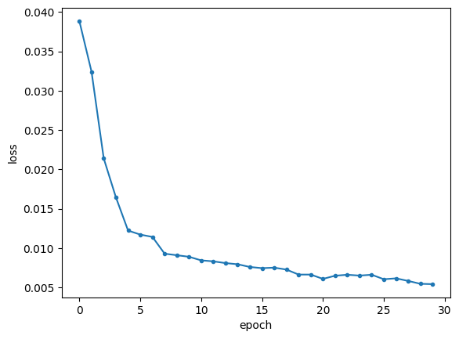

Figure XXVIII: Loss Curve of Training for MNIST Dataset

In the figure below are examples of the moving, fixed, moved and flow images for the MNIST dataset.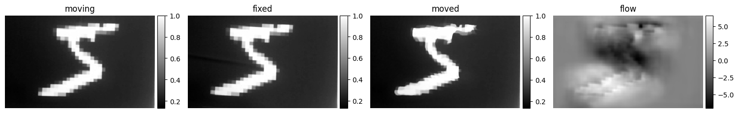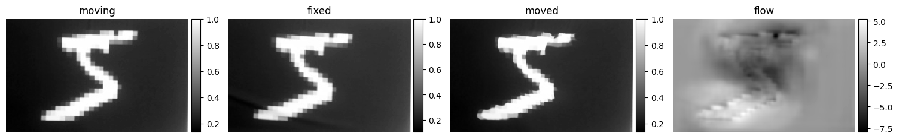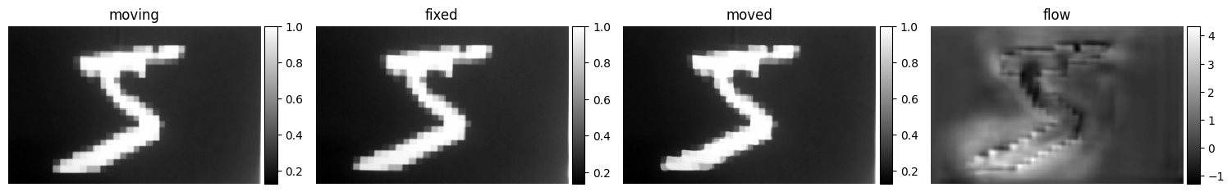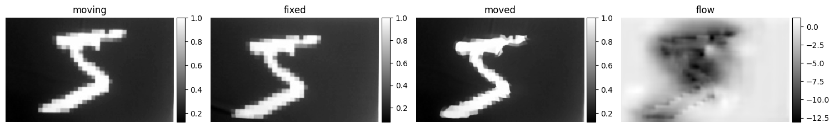

Figure XXIX: Moving, Fixed, Moved and Flow Images for MNIST Dataset

The figure below shows the training curve of the brain MRI dataset which reaches a loss of around 0.08 at 200 epochs.

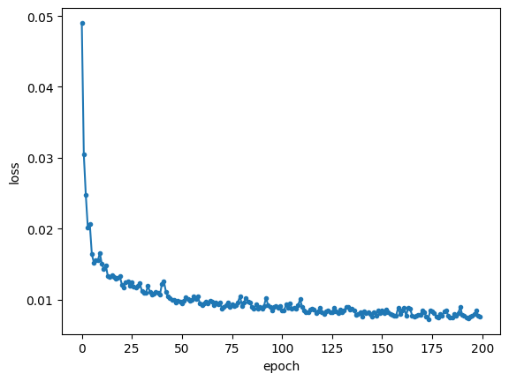Figure XXX: Loss Curve for Training of Brain MRI dataset

In the figure below are examples of the moving, fixed, moved and flow images for the brain MRI dataset.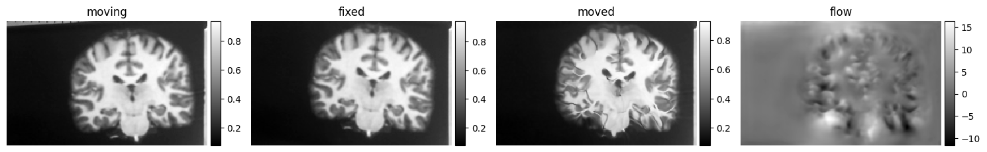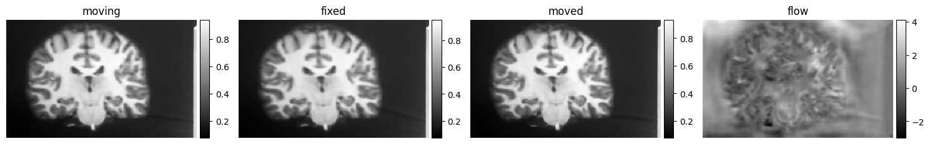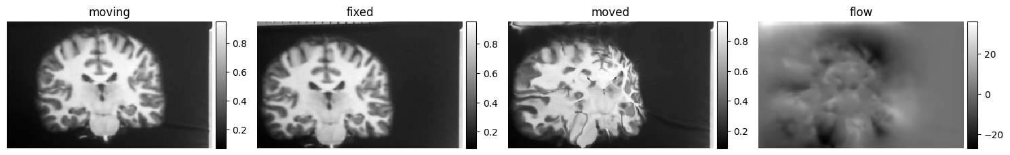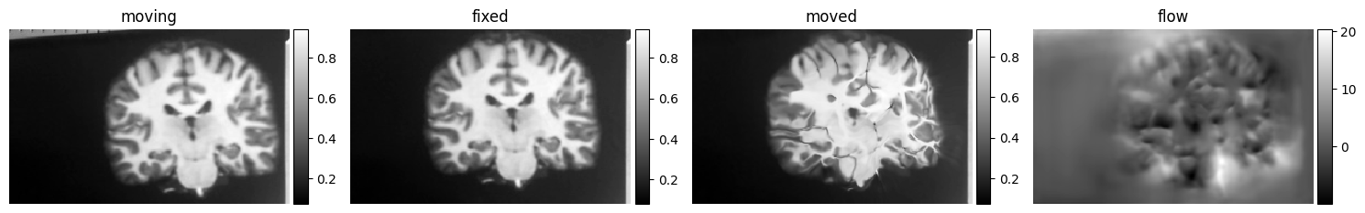

Figure XXXI: Moving, Fixed, Moved and Flow Images for Brain MRI Dataset

3.11 Running the Code and Launching Nodes

The code is separated into several ROS nodes with different functionalities to be launched and run at different times. The detailed instructions of how to run the code is found in Appendix A. The first thing to run is the camera node. You would need to SSH into the Raspberry Pi and open the Docker container to access the program. Once inside the Docker container, access the ROS workspace and run the camera node. Make sure the camera is streaming images by looking at the terminal to see if the images have been taken and published. Next, open the 3D Slicer app. Make sure the workspace is built and sourced using the colcon build and source command in Appendix A. The first thing to do after 3D Slicer is run is to click on the drop down menu, hover over the “Examples” tab and select the ROS2 extension. By selecting the ROS2 extension it will make sure the code we built is running. Next go to the volume rendering tab and find if the Volume named Volume is available. If it is not available, something may be wrong and the Slicer application should be restarted or the workspace may need to be sourced again. If the Volume is available, select it and click on the eye icon next to the dropdown menu. The image should show up in the 3D Slicer scene and it should live update every couple of seconds. Put your hand under the camera to make sure the image is updating. Next, the robot model can be brought into the 3D Slicer scene. First run the two panda model nodes as stated in Appendix A. One of the nodes loads a URDF file of the robot and the other node starts a robot state and joint state publisher. The Slicer-ROS2-Module is based upon the robot state and joint state publishers to update the robot position in the 3D Slicer scene. Make sure once the robot is loaded the nodes are killed. The reason is that the MoveIt code will also start a robot and joint state publisher and the two will conflict with each other. Next, start the image registration node. Make sure the image is in the right spot when the node starts because the first image that gets published to the node when it starts will be the fixed image. All subsequent images received by the node will update the moving image. Make sure the message “Model Initialized'' can be seen in the terminal before running other nodes. Next, launch the first MoveIt launch file. This launch file launches all the nodes required for the MoveIt code to run including a robot and joint state publisher, controllers, and a move group node for MoveIt. Make sure both the joint state publisher and controller is loaded. This launch file may have some issues not launching all the nodes sometimes, but the launch file will launch everything after either rerunning the command, rebuilding and resourcing the workspace, restarting the robot or just waiting for a certain amount of time. Make sure you see the green message “You can start planning now” before starting the other MoveIt node. The robot should move to a new home position immediately after the node is run. Then after adding fiducial markups to the scene and adding them to the path, when the trace path button is pressed, the MoveIt node will move the robot to the desired positions. Note that when the trace path button is pressed, the latest image the image registration node receives will be the moved image for image registration. If the image registration node is active, the robot will move to the spot after being displaced by the deformation field.

3.12 Publishers/Subscribers and Topics

The camera publishes images every 0.5 seconds or at 120 Hz to both the image registration and 3D Slicer nodes using the /image_topic topic. The messages are encoded in an ROS image message. The panda_model and test_joint_state_publisher nodes publish the URDF and “fake” joint state messages over the /measured_js topic to the 3D Slicer node. Once again these nodes are only run to load the robot model into the 3D Slicer scene and are killed once they have been used. The 3D Slicer node publishes to the trace_path node over the topic /path_topic where the robot should move to using PoseArray messages listing a series of points and orientations for the robot to go through. For simplicity, all orientations should be pointing directly into the plane due to operation on a flat surface. Depending on whether or not image registration is on, the PoseArray messages may first be passed to the image registration node over the /image_reg_topic and modified due to the deformation field. The PoseArray messages would then be passed back over the /moved_path_topic to the 3D Slicer node and this modified PoseArray message would be sent to the trace_path node over the /path_topic. The trace_path topic sends commands to the move_it nodes which are a series of pose or joint state messages for the robot to move to using MoveIt’s Move Group Interface. Note that move_it actually represents a series of nodes including a move_group_node which interacts with MoveIt’s Move Group Interface, planning nodes, controller nodes, a joint state broadcaster and a robot state broadcaster. The joint and robot state broadcasters control the position of the robot in the 3D Slicer scene when the robot moves in the real world and the joint state broadcaster once again publishes messages over the /measured_js topic. It can be seen why “fake” joint state publisher needed to be killed, otherwise the two nodes would be publishing conflicting messages over the /measured_js topic. The controller node in move_it sends joint state messages to the servo motors in the robot over the /servo_js topic in order to move the real world robot.

You can see an overview of the node structure and topics in the figure below. The nodes and states are in blue and the topics are in orange. The green represents either commands or files being sent.

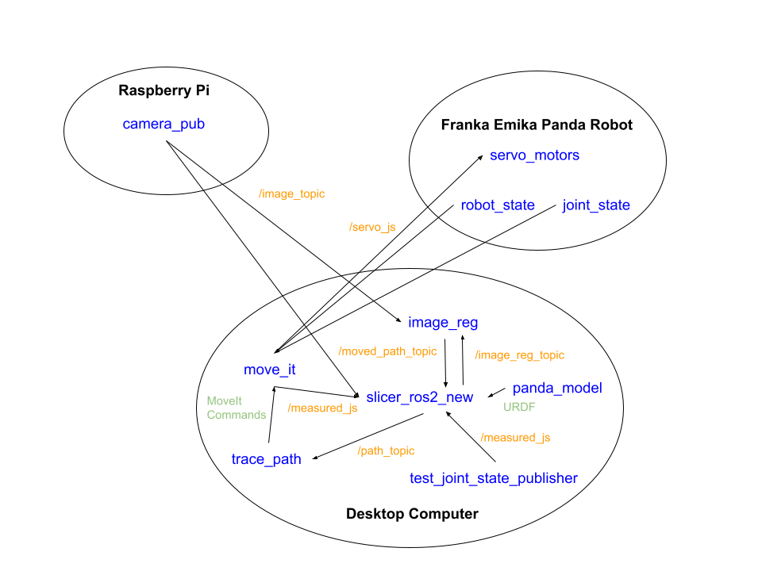

Figure XXXII: Node and Topic Graph for Image-Guided Robotics System

3.13 Slicer_ROS2_New Node In Detail

Slicer_ROS2_New is the node that handles most of the logic in 3D Slicer including the interaction with the new user interface (UI) that was designed for the extension. Once again, the code is built upon the existing Slicer_ROS2_Module code that can load the robot into 3D Slicer using STL files. The UI was created using QT Designer and the project added to the existing UI that was for the Slicer_ROS2_Module. Read the documentation in their Github repository for more details. 3D Slicer needs to be built from source in order for the code to work.

The code is split into 3 different sets of .cxx and .h files. The first set is qSlicerRos2Module files which sets up and loads the new extension in 3D Slicer as well as setting up the logic in 3D Slicer. Next is the qSlicerRos2ModuleWidget files, which interacts with the new UI for the extension, for example when buttons are pressed or items are selected from drop down menus. Finally, the last set of files are the qSlicerRos2ModuleLogic files which hold the majority of the code that performs calculations and interacts with 3D Slicer.

The qSlicerRos2Module files stayed the same compared to the existing code. The UI was changed including the addition of a vtkMRMLNodeComboBox which could be used to select certain vtkMRMLMarkupNodes to add to the path for the robot to trace, add to path and remove from path buttons to add the selected markup in the combo box to the desired path or remove the previously added markup from the desired path, a display to show the current path, and a trace path button to command the robot to trace the desired path consisting of the markups. Code was added to the qSlicerRos2ModuleWidget files to accommodate these changes and implement these functionalities. The majority of the code used the QT programming library to implement the UI interaction and functionality.

The area where the most code was added was the qSlicerRos2ModuleLogic files. This file did all the 3D Slicer and ROS2 integration. All the ROS2 publishers and subscribers were added to the C++ constructor for the module, including the subscriber for the /image_topic, the subscriber for the /moved_path_topic, the publisher for the /image_reg_topic, and the publisher for the /path_topic.

The main function that was added to the file was the trace_path function for the logic for the trace path button. The code for the qSlicerRos2ModuleLogic accumulated a vector of vtkMRMLNode pointers for each of the markups added to the path and the vector is passed to the trace_path function. The trace path function takes the vtkMRMLNode pointers and converts them to the specific variable type for each markup pointer. There are many different markups in 3D Slicer including fiducials, closed and open curves, lines, and planes. Originally the plan was to be able to trace any number of paths of any different markup type, but there was only time to debug the code to trace the paths made by a collection of fiducials. There are a set of functions for each markup type that can be used as part of the 3D Slicer custom libraries. The functions used in the code included a function getClassName() gets the markup type of the node, GetNumberOfFiducials() gets the number of fiducials in a vtkMRMLFiducialNode, GetNthFiducialPosition() gets the position of the nth fiducial in a vtkMRMLFiducialNode. Another important function was the SafeDownCast() function that allowed C++ classes to convert to classes lower in the C++ inheritance hierarchy diagram, or more specific classes if it was allowed. Normally only converting to classes higher in the C++ inheritance hierarchy is allowed. Once the position of the fiducials in the 3D Slicer scene is determined, they must be transformed to the world frame. Then the positions are converted into a PoseArray message and sent to the trace_path node. It was assumed that there was a transformation between the 3D Slicer frame and the world frame but after calibration it was determined that there was no transformation between the 3D Slicer frame and the world frame. Only a conversion from millimeters in the 3D Slicer frame to meters in the world frame was required for the PoseArray message.

Some additional code is added in case image registration is turned on. If the image registration is turned on, the PoseArray message is actually sent to the image_reg node first via the /image_reg_topic to transform the PoseArray points according to the deformation field. The code then waits for the message to come back to the node via the /move_path_topic before executing the next code. Implementing the wait for the message to come back was actually quite difficult. ROS1 has the function wait_for_message() for a specified subscriber but ROS2 does not have an equivalent function for rclcpp. A ROS2 service could be used for ROS2 but services are actually quite difficult to implement in rclcpp. Instead, waitsets are used to wait for a certain amount of time for a message to arrive, otherwise it fails. The coordinates in the PoseArray messages are converted back to 3D Slicer coordinates and the function SetNthControlPointPosition() is used to update the position of the fiducial markups after registration. Finally, the code publishes the altered PoseArray message to the /path_topic to be sent to the trace_path node.

The secondary function that was added to the file was the DisplayImage function to display the image seen by the camera in the 3D Slicer scene. After receiving the image messages from the Raspberry Pi camera, there is a callback function that translates the image message using cv_bridge and saves it to a cv_image pointer. The DisplayImage function converts the image which is in the form of a cv::Mat class, the default class for images in the OpenCV2 library for C++, into vtkImageData. The vtkImageData takes 3D input so a second copy of the image is stacked on top of the first copy to create a volume. A thing to note is that OpenCV has their imaging coordinate system origin in the top left corner of the image, with the x-axis pointing from left to right and the y-axis pointing from the top to bottom. VTK on the other hand has their imaging coordinate system origin in the bottom left corner of the image with the x-axis pointing from left to right and the y-axis pointing from the bottom to the top. So the image has to be flipped along the x-axis when converting from OpenCV to VTK data. The VTK library is useful for modeling applications in software and is used heavily with 3D Slicer.

The reason we require vtkImageData is because we try to load the image into the 3D Slicer scene by using a vtkMRMLScalarVolumeNode. The scalar volume indicates that each voxel holds a value which is often intensity data. Often MRI and other grayscale imaging data is stored in scalar volumes. We again use functions from the 3D Slicer custom libraries including SetAndObserveImageData() which loads the vtkImageData into the scalar volume node. The most important function is addNode() which adds the vtkMRMLScalarVolumeNode to the 3D Slicer scene. We set the origin and spacing of the vtkMRMLScalarVolumeNode to make sure it is in the right spot in the 3D Slicer scene and each pixel represents a specific area in the real world. We also use the function CreateDefaultDisplayNodes() to create a vtkMRMLScalarVolumeDisplayNode in order to display the volume in the 3D Slicer scene.

3.14 Image_Reg Node In Detail

The image registration node runs one Python file to transform the input PoseArray message with the deform field and outputs the transformed PoseArray message. Remember each PoseArray message represents the path created by a single markup. If multiple paths are formed by different markups and they need to be combined, multiple PoseArray messages will be sent. The reason Python is used here is because it allows us to use Numpy, Tensorflow and other useful machine learning libraries for image registration which are all useful deep learning packages. Luckily ROS allows us to run multiple packages in both C++ and Python that are able to communicate with each other via topics. The image registration node subscribes to the /image_topic and the /image_reg_topic and publishes messages over the /moved_path_topic. What the code does is that it first sets up the VoxelMorph model and loads the pretrained weights from a .h5 file when the node starts. When the node starts, the first image the node receives over the /image_topic will be the fixed image for registration. Every other image the node receives will update the moving image. When the node receives a message over the /img_reg_topic, the program immediately performs a registration on the current fixed and moving images and updates the deformation field. Then the node transforms the PoseArray messages into the image frame in order to find the right pixels to examine in the deformation field. The displacements are then added to the desired poses in the images frame and then transformed back again to the robot and world frame. Then the message is finally sent over the /moved_path_topic to the Slicer_ROS2_New node.

3.15 Trace_Path Node In Detail

The trace_path node receives a series of PoseArray messages from the Slicer_ROS2_New node to control where the robot moves. The trace_path node converts a .cpp file to an executable that is run when a launch command is called. The reason C++ is used here is because the MoveIt library only has C++ integration. Again, luckily ROS’s package structure allows us to code in both C++ and Python. C++ just makes more sense here. The first thing the node does when it is run is set up the logic for MoveIt. The code uses move groups to control the robot and it initializes the move group to the “panda_arm”. Next, the code controls the robot to move to a predetermined joint position that has favorable access to the whole MRI image printed on the fabric. The code uses the set_joint_value_target() MoveIt function which takes a JointState message to set a joint pose goal, then uses the move() function to control the robot to move to the target joint state.

The incoming PoseArray messages are sorted in a queue to preserve the order that the PoseArray messages arrive. Remember each PoseArray message represents the path created by a single markup. If multiple paths are formed by different markups and they need to be combined, multiple PoseArray messages will be sent. Each PoseArray message is popped out of the queue when there is one available and the robot has already done the desired trajectory for the previous PoseArray message.

When the queue is not empty, the code pops the PoseArray message in the front of the queue and breaks the PoseArray into a series of Pose messages in order. These Pose messages are added to a vector which the MoveIt function compute_cartesian_path() takes in to compute a smooth trajectory that passes through all the poses in the vector. Once the trajectory is calculated by the function, the MoveIt function execute() will control the robot to perform the trajectory.

3.16 Camera_Pub Node In Detail

The camera publisher node is located in the Raspberry Pi. The ROS node is coded in Python because OpenCV and Numpy are used a lot for capturing image data and it is easier to use in Python. The functionality of this node is pretty simple. The code sets up the Raspberry Pi to take color images using the Raspberry Pi camera by setting the dimensions of the image and taking captures of the current frame. Then the node encodes the image which is currently in the form of a Numpy array to a ROS Image message using the cv_bridge library and publishes it over the /Image_topic. What is actually happening is that the Raspberry Pi is constantly capturing a live video feed which is located at /dev/video0 in the Docker container and the program just captures a frame in the video feed at a specific time. What the node does is that it uses a ROS2 timer to take a frame capture every 0.5 seconds or 2 Hz and publishes the image.

3.17 Calibration and Frame Transformations

Calibration and frame transformations were two topics that needed to be solved for this project. There are 3 major reference frames to keep track of here. First is the robot or world frame. All the commands to the robot are sent in the robot or world frame and everything is measured in the real world from there. The next frame is the 3D Slicer frame and how everything is positioned in the 3D Slicer frame. The last frame is the 2D camera imaging frame. The transformations needed are the transformation between the 3D Slicer frame and the robot or world frame and its inverse transformation, as well as the transformation between the world frame and the imaging frame and its inverse transformation. It is reasonable to assume that the transformations would be rigid frame transformations and not deformable transformations. The problem is to find these transformations which can be difficult to solve. Typically in the camera imaging frame, the Instead of typical Cartesian XYZ coordinates, 3D Slicer uses the RAS coordinate system which stands for Right, Anterior, Superior based on the anatomical system or space which is the most important model coordinate system for medical imaging techniques.

The anatomical space consists of three planes to describe the standard anatomical position of a human. The axial plane is parallel to the ground and splits the head (Superior) and the feet (Inferior). The coronal plane is perpendicular to the ground and splits the front (Anterior) and the back (Posterior). The sagittal plane splits the Left from the Right. The anatomical coordinate system is a continuous three-dimensional space for a 3D image that has been collected by a medical device. It is common in neuroscience to define the anatomic coordinate system with respect to the human whose brain is being scanned. The 3D basis is defined by the anatomical axes of anterior-posterior, inferior-superior, and left-right.

Determining the transformations was quite difficult in this instance because none of the common calibration methods seemed to produce adequate results. Since the project is so large, it doesn’t make sense to spend too much time on calibration. The first transformation method we tried was scalar weighted point cloud alignment. The method includes finding many point correspondences between the two frames and trying to align all the point correspondences as best as possible and returning a transformation. The method involves computing the centroids of all the points measured in each frame and computing the outer product of the differences between each of the points and the centroid in their frames to get a series of weight matrices. The matrices are then summed together and a Singular Value Decomposition (SVD) is calculated. The rotation matrix and the translation vector are found after doing some further math. The method was programmed using Python in Google Colab because it allowed easy access to math based Python libraries like NumPy and SciPy. Further information about scalar weighted point cloud alignment can be found here[]. The process of finding point correspondences involved physically measuring the distance of a point measured from the origin of the robot and finding the same point in 3D Slicer coordinates using the location of markup points. In order to get good measurements, the end effector of the robot was used as a reference point and the robot model with a robot and joint state publisher was loaded into 3D Slicer so the same location on the end effector of the robot could be found in the 3D Slicer frame. 10 point correspondences were used and the calibration method proved to not be effective in finding the transformation by getting ridiculously high translations. Either there was something wrong in the code, the point correspondences were incorrect or inaccurate, or not enough point correspondences were collected. A Github repository was found online that performed scalar weighted point cloud alignment but it also gave incorrect transformations that had ridiculously high translations.

After some further investigation and moving the robot using the MoveIt code, it was found that coordinate reference frames being measured from were incorrect. In reality the 3D Slicer and Robot/World Frames were exactly aligned, just measured in different units. 3D Slicer uses millimeters and the Franka Emika Panda robot uses meters. The RAS coordinates in the anatomical 3D Slicer coordinate system directly correspond with the XYZ coordinates in the Cartesian world coordinate system.

The more difficult part was finding the transformation between the Robot/World frame and the imaging frame. The first method that was considered was to find the exact camera matrix to transform a 3D world point to a 2D image point using camera calibration and camera pose estimation. First find the camera intrinsics and then to do camera pose estimation to estimate the pose of the camera using checkerboard points. The camera calibration process is pretty thoroughly documented in the OpenCV documentation[]. From a previous Computer Vision course, a program was made that was able to estimate the pose of the camera from images of a checkerboard in different orientations and the exact location of the checkerboard points in the real world. We determined that a full camera calibration process was not needed since we were taking images of a flat surface and it was not worth spending too much time on this.

The next camera calibration method was actually implemented in code in Google Colab by using the solvePNP() function from OpenCV[]. The PNP problem refers to the Perspective-N-Points problem in which you take N point correspondences to try to determine the camera matrix using the direct linear transform (DLT) algorithm. DLT is an algorithm that solves for unknowns in a transformation matrix using point correspondences, often used in projective geometry or imaging. It is optional to give the function a camera intrinsics matrix. Without a camera intrinsic matrix, more point correspondences would be needed, but DLT will still work regardless. The fact that a camera intrinsic matrix is not required is good for our purposes since we don’t want to spend time determining the camera intrinsic matrix. The point correspondences were determined by physically measuring points in the robot frame from the origin and finding the location of the same point in the camera image. It was pretty easy to find correspondences because the optical table surface provided many reference points at exact intervals. The imaging software IrfanView 64[] was able to show the location of a particular pixel in an image where the computer cursor was on so finding point correspondences just involved hovering the cursor at the corresponding point in the image. 15 point correspondences were used and unfortunately this camera calibration method did not produce the best results. The location of a transformed point differed greatly, about 0.5 meters than what was expected after being transformed by the resulting camera matrix.

Due to the lack of time, the simplest solution for finding a transformation method was just to find the point correspondences of the four corners of the image, again using the physical measurement method, and finding the length and width that the image represents in the real world to get the length and width of one pixel. The length and width of the image was found by taking a picture of measuring tape and reading the length and width of the image from the tape measure. The information about the length and width of each pixel as well as the location of the corner of the image in world coordinates was useful for determining the origin and spacing of the imaging data and scalar volume in the 3D Slicer. Note that this means of calculating the transformation is by no means accurate, but it was the best result that was found.

3.18 Experimental Methods

Here are the experiments to be conducted on the finished image-guided robotics system. All the experiments will be conducted on the brain MRI scan and not the MNIST digit image to more accurately simulate a real life situation and due to the lack of time to do the project. First we test the image-guided robotics system without image registration on a fixed image and recording the differences between the requested and actual position of the robot. The requested position of the robot will be marked by fiducial markups in 3D Slicer and the actual position of the robot will be measured using physical measurements from the robot origin. Next we test the image-guided robotics system with image registration by moving the fabric with a constant displacement to see how well the system’s registration responds to pure displacements. We also test the image-guided robotics system with image registration by deforming the fabric a constant amount to see how well the system responds to deformations.

For the experiments with image registration, the desired points on the fixed image in the 3D Slicer scene will be marked by a fiducial point that would be added to the path later. Then the image is displaced and the same location of the brain is marked by a second fiducial markup. The location of the second fiducial markup will be recorded as the desired location for the robot to move to. The deformation or displacement in the two experiments should try to be as consistent as possible over all trials and the location of the second fiducial markup compared to the first should be a somewhat decent indicator of the consistency of each trial. Note that the location of the second fiducial markup should not be added to the traced path. Next, the trace path button can be pressed and the location of the first markup will be updated to where the robot travels to and where the system thinks the updated location is. The physical robot will move in the real world as well. Physically measure the location of the end effector of the physical robot from the robot origin which will be recorded as the actual location of the robot and compare it to the location of the second markup point in the 3D Slicer scene.

An experiment with both a displacement and a deformation would have been performed but there was no time to do so. It would also be interesting to compare the performances between the image guided robotics system without the image registration and with the image registration on the same task, but the system without registration would perform similarly to how it performed on the fixed image if the same points are used.

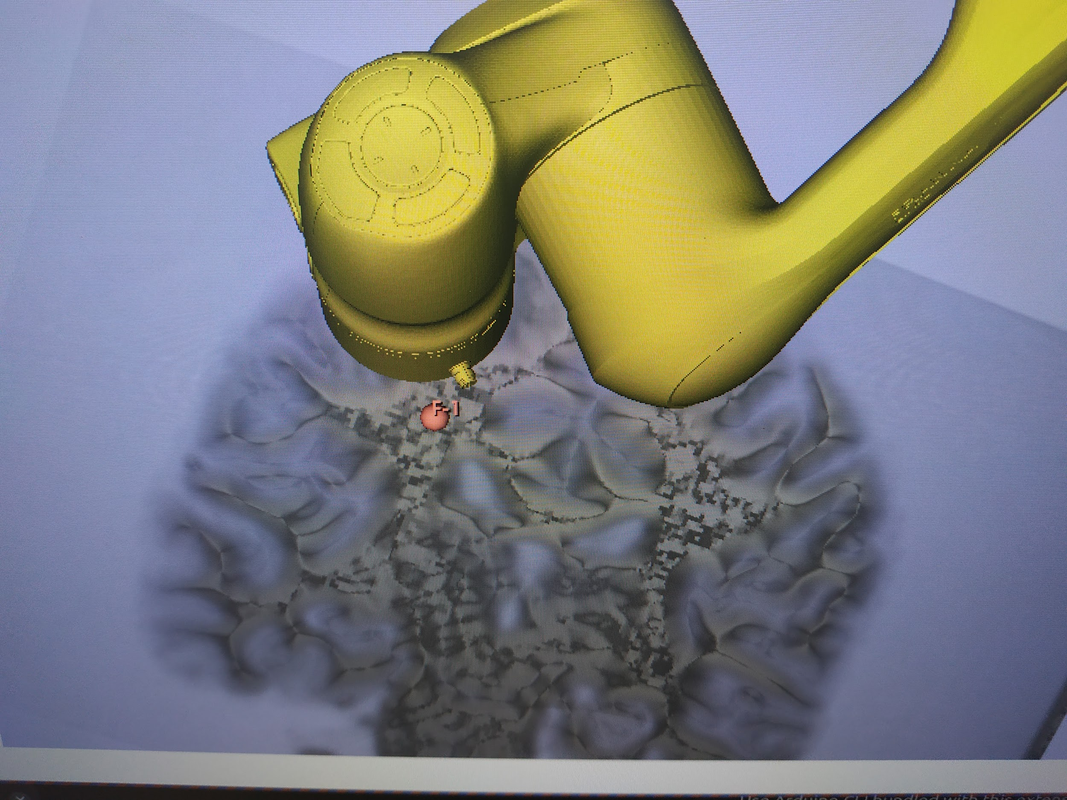

Figure XXXIII: Image of 3D Slicer Scene with Robot and Brain MRI

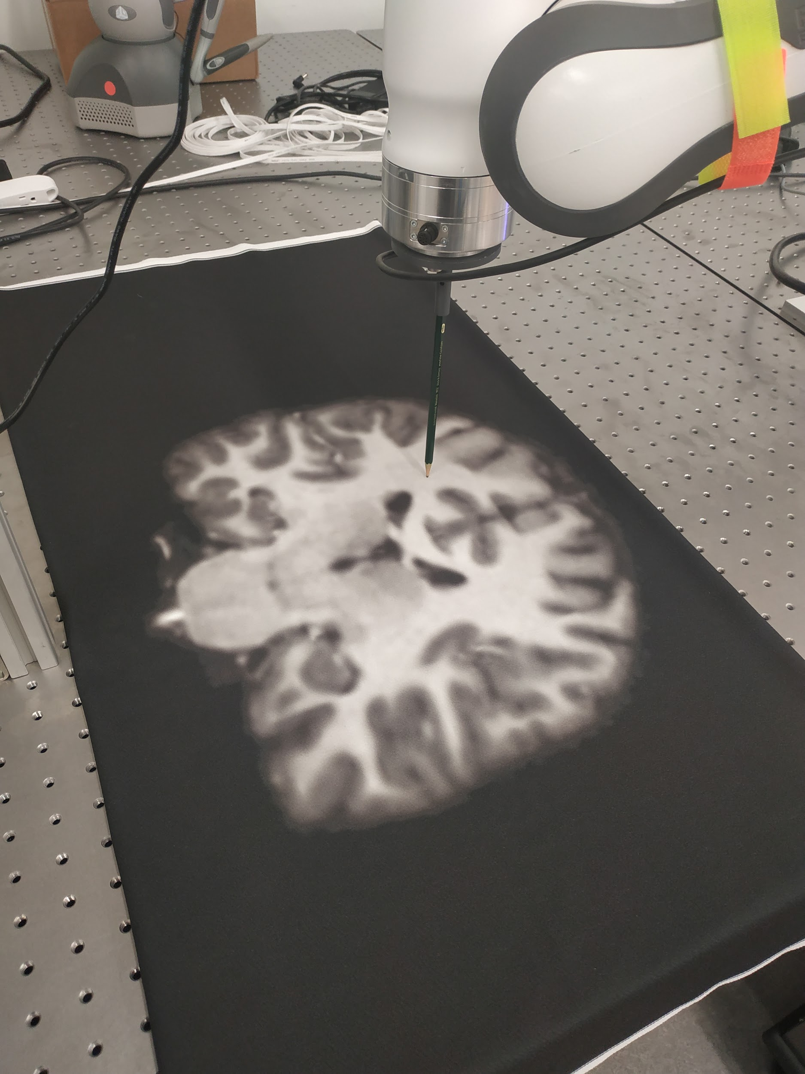

Figure XXXIV: Image of Experimental Setup with Robot and Brain MRI

**4 Results and Discussion:**

4.1 Performance of Image-Guided Robotics System without Image Registration on Fixed Images

The locations of desired positions are labeled by markup fiducial points in the figure below. These desired positions are used roughly as a guideline for all experiments.

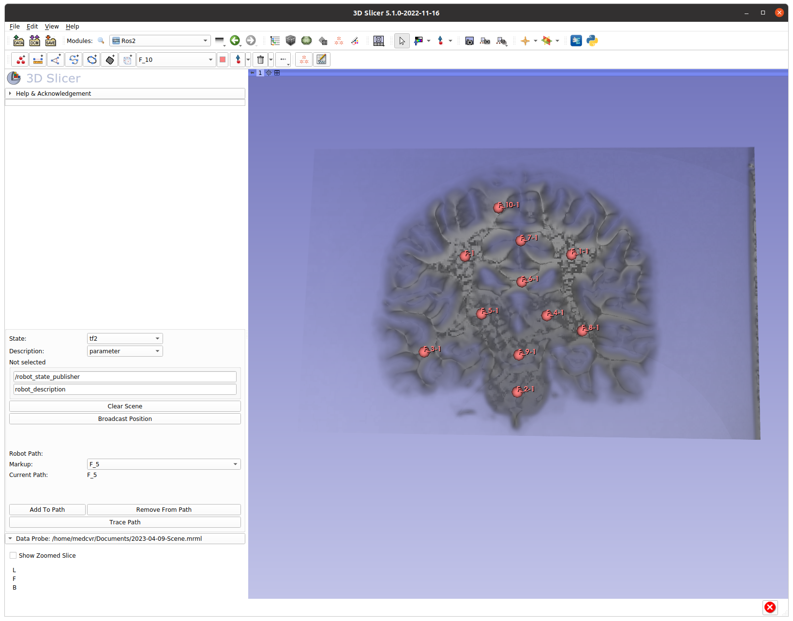

Figure XXXV: Location of Fiducial Points for Experiment

The results of the Requested vs Actual Position of the Robot is displayed in the figure below.

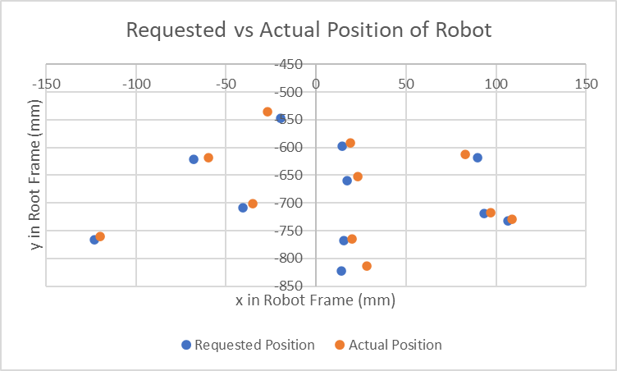

Figure XXXVI: Requested vs Actual Position of Robot for First Experiment

In the next figure, the error of the position of the robot is shown.

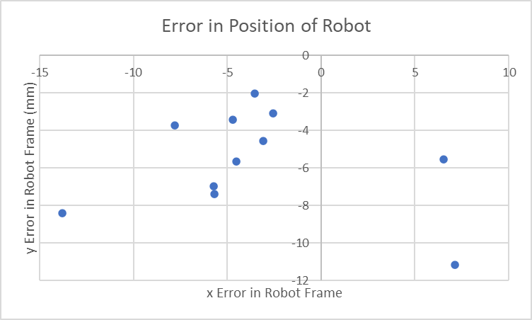

Figure XXXVII: Error in Position of Robot for First Experiment

As can be seen from the two figures, the error seems to skew in the negative x and negative y direction except for two points. The average error in both the x in y directions seem relatively similar, around 5mm error in each direction. In the next figure, the error magnitude of each point is shown, with each point corresponding with the numbered fiducial in Figure X.

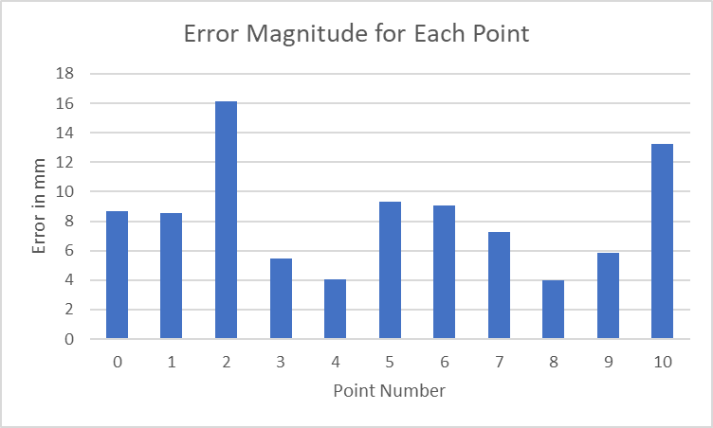

Figure XXXVIII: Error Magnitude for Each Point of First Experiment

As can be seen by the error magnitude of each point the average error is around 8mm which is good for an image guided robotics system, even though 8mm would be much too high an error for real surgical applications

All the data available for this experiment is displayed below in table form.

|  |  |  |  |  |  |  |  |
| --- | --- | --- | --- | --- | --- | --- | --- |
| No Image Registration Fixed Image Only |  |  |  |  |  |  |  |
|  | Requested Position |  | Actual Position |  | Error |  | Error (Mag) |
| Trial | x | y | x | y | x | y |  |
| 1 | -67.804 | -621.726 | -60 | -618 | -7.804 | -3.726 | 8.647860545 |
| 2 | 89.532 | -618.534 | 83 | -613 | 6.532 | -5.534 | 8.561085212 |
| 3 | 14.207 | -822.388 | 28 | -814 | -13.793 | -8.388 | 16.14327702 |
| 4 | -123.088 | -765.541 | -120 | -761 | -3.088 | -4.541 | 5.491486593 |
| 5 | 93.47 | -719.025 | 97 | -717 | -3.53 | -2.025 | 4.06958536 |
| 6 | -40.695 | -708.398 | -35 | -701 | -5.695 | -7.398 | 9.336135657 |
| 7 | 17.264 | -659.976 | 23 | -653 | -5.736 | -6.976 | 9.031404763 |
| 8 | 14.471 | -597.648 | 19 | -592 | -4.529 | -5.648 | 7.239595638 |
| 9 | 106.452 | -732.072 | 109 | -729 | -2.548 | -3.072 | 3.991176268 |
| 10 | 15.293 | -768.427 | 20 | -765 | -4.707 | -3.427 | 5.822385937 |
| 11 | -19.861 | -547.141 | -27 | -536 | 7.139 | -11.141 | 13.23205207 |

Table III: Data for First Experiment

4.2 Performance of Image-Guided Robotics System with Image Registration on Moving Images With Constant Displacement

The results of the Requested vs Actual Position of the Robot is displayed in the figure below after registration on a moving image a constant 150 mm from the fixed image.

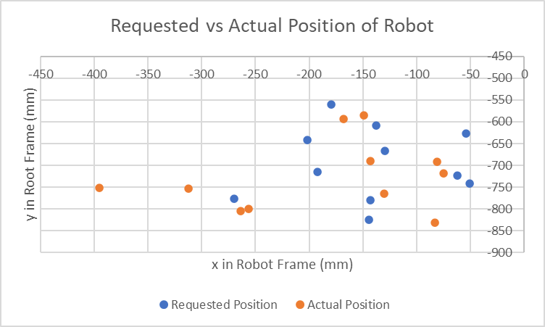

Figure XXXIX: Requested vs Actual Position of Robot for Second Experiment

In the next figure, the error of the position of the robot is displayed.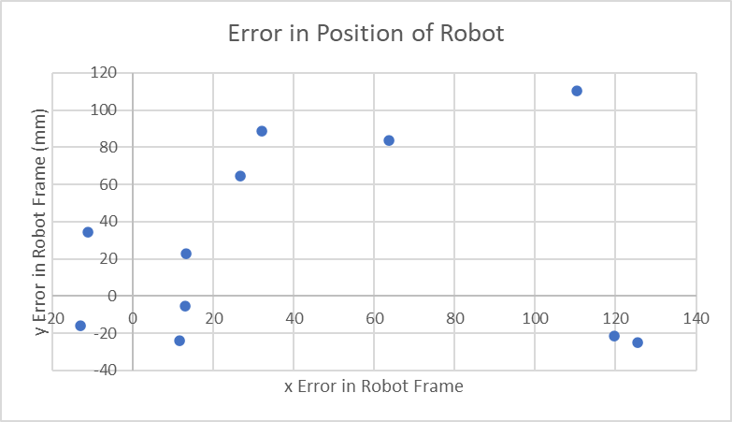

Figure XL: Error in Position of Robot for Second Experiment

There does not seem to be many trends in the data except that the error tends to skew a lot in both the positive x and y directions. In the next figure, the error magnitude of each point is shown, with each point corresponding with the numbered fiducial in Figure X.

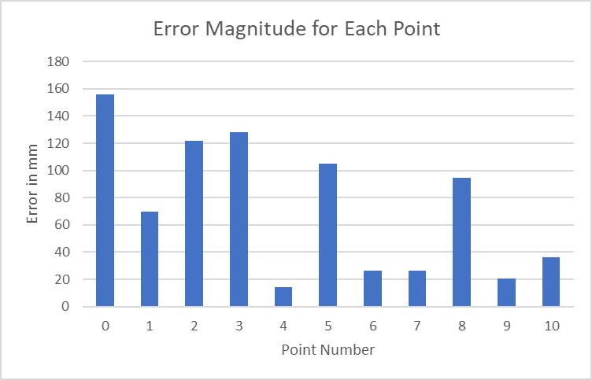Figure XLI: Error in Magnitude of Each Point In Second Experiment

As can be seen from the figure of the error magnitude of each point, it seems that the error for image registration for displacements can be pretty high, even reaching 120-150 mm, with a couple pretty good registrations with 20 mm error. We can see that the image registration method is pretty inconsistent for large displacements. The table with all the data for the experiment is displayed below.

|  |  |  |  |  |  |  |  |
| --- | --- | --- | --- | --- | --- | --- | --- |
| Image Registration Constant Displacement = 150mm |  |  |  |  |  |  |  |
|  | Requested Position |  | Actual Position |  | Error |  | Error (Mag) |
| Trial | x | y | x | y | x | y |  |
| 0 | -201.745 | -642.538 | -312 | -753 | 110.255 | 110.462 | 156.070556 |
| 1 | -54.321 | -627.491 | -81 | -692 | 26.679 | 64.509 | 69.8081666 |
| 2 | -144.286 | -825.479 | -264 | -804 | 119.714 | -21.479 | 121.625611 |
| 3 | -269.509 | -775.982 | -395 | -751 | 125.491 | -24.982 | 127.953474 |
| 4 | -61.937 | -723.234 | -75 | -718 | 13.063 | -5.234 | 14.0725522 |
| 5 | -192.378 | -715.314 | -256 | -799 | 63.622 | 83.686 | 105.124238 |
| 6 | -129.796 | -667.396 | -143 | -690 | 13.204 | 22.604 | 26.1779761 |
| 7 | -137.451 | -608.731 | -149 | -585 | 11.549 | -23.731 | 26.3920397 |
| 8 | -50.892 | -742.095 | -83 | -831 | 32.108 | 88.905 | 94.5252489 |
| 9 | -143.032 | -779.81 | -130 | -764 | -13.032 | -15.81 | 20.488756 |
| 10 | -179.169 | -559.655 | -168 | -594 | -11.169 | 34.345 | 36.115448 |

Table IV: Data for Second Experiment

4.3 Performance of Image-Guided Robotics System with Image Registration on Moving Images With Constant Deformation

The results of the Requested vs Actual Position of the Robot is displayed in the figure below after registration on a moving image deformed 50 mm from the fixed image.

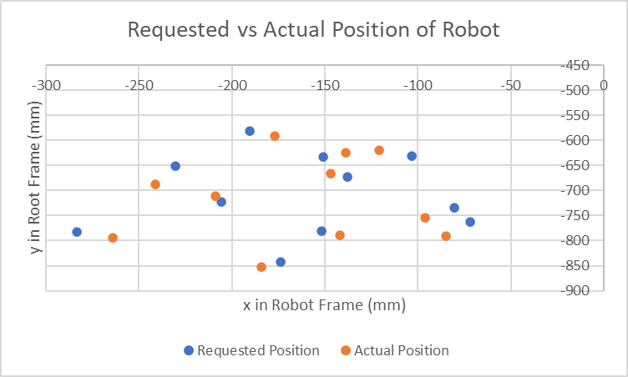

Figure XLII: Requested vs Actual Position of Robot In Third Experiment

In the next figure, the error of the position of the robot is displayed.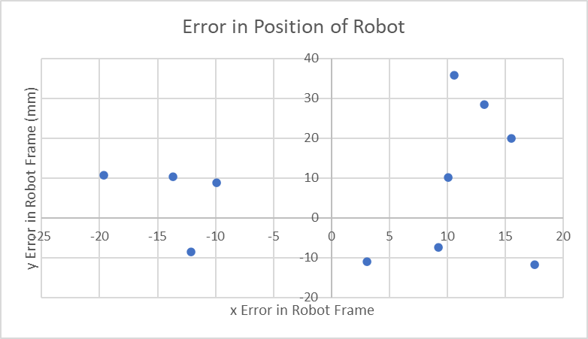

Figure XLIII: Error In Position of Robot In Third Experiment

There does not seem to be many trends in the data as the error in the position of the robot seems to be quite evenly distributed. There seems to be a spread in the error about 20 mm in the x direction and a spread in error about 40 mm in the y direction. In the next figure, the error magnitude of each point is shown, with each point corresponding with the numbered fiducial in Figure X.

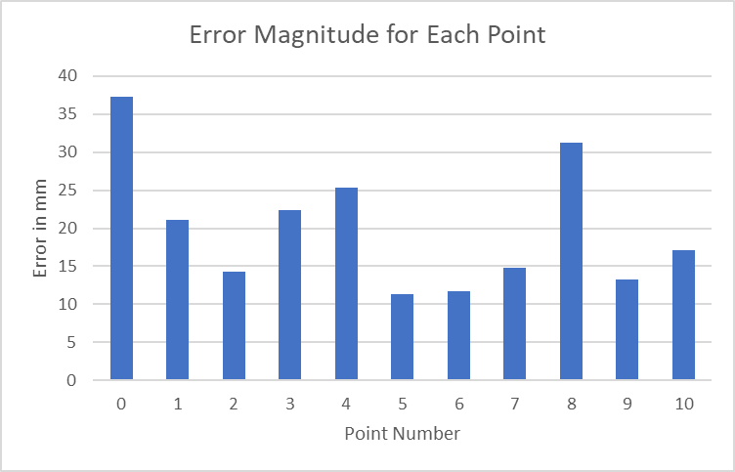

Figure XLIV: Error In Magnitude of Each Point in Third Experiment

As can be seen from the figure of the error magnitude of each point, it seems that the error for image registration for deformations is not as high which is to be expected since the stretch is not by much, only 50 mm. The error reaches a peak of less than 40 mm, with a couple pretty good registrations with 15 mm error. We can see that the image registration method does okay on large deformations. The table with all the data for the experiment is displayed below.

|  |  |  |  |  |  |  |  |
| --- | --- | --- | --- | --- | --- | --- | --- |
| Image Registration Constant Deformation = 50mm Stretch |  |  |  |  |  |  |  |
|  | Requested Position |  | Actual Position |  | Error |  | Error (Mag) |
| Trial | x | y | x | y | x | y |  |
| 0 | -230.392 | -651.274 | -241 | -687 | 10.608 | 35.726 | 37.2676366 |
| 1 | -103.43 | -631.702 | -121 | -620 | 17.57 | -11.702 | 21.1102275 |
| 2 | -173.92 | -842.893 | -184 | -853 | 10.08 | 10.107 | 14.2743774 |
| 3 | -283.672 | -783.357 | -264 | -794 | -19.672 | 10.643 | 22.3665159 |
| 4 | -80.431 | -734.093 | -96 | -754 | 15.569 | 19.907 | 25.2721667 |
| 5 | -205.938 | -721.903 | -209 | -711 | 3.062 | -10.903 | 11.324807 |
| 6 | -137.766 | -673.32 | -147 | -666 | 9.234 | -7.32 | 11.7834272 |
| 7 | -151.098 | -632.487 | -139 | -624 | -12.098 | -8.487 | 14.7780504 |
| 8 | -71.804 | -762.636 | -85 | -791 | 13.196 | 28.364 | 31.2833967 |
| 9 | -151.892 | -781.243 | -142 | -790 | -9.892 | 8.757 | 13.2112343 |
| 10 | -190.641 | -581.734 | -177 | -592 | -13.641 | 10.266 | 17.0724233 |

Table V: Data For Third Experiment

4.4 Discussion of Results and Sources of Error

The results of the image-guided robotics system experiments seem to be pretty good in general. The result on the fixed images with no image registration seem to be very good with only 8 mm error. The system using registration does not really perform that well on images with large displacements but performs decently on images with somewhat large deformations. It seems likely from the observations that the system would perform better if the displacement was not too large. Unfortunately, there was not enough time to perform another experiment with a smaller displacement.

There are two main possible sources of error for the image-guided robotics system. The first source of error is obviously the image registration. Since we don’t have the ground truth for the required displacement of each image, the deformation flow field had to be observed to see if it made sense after pre-training each time and if the loss was decently low. If the optimal hyperparameters could be found and many models could be tested on the robot, we would likely get better and better results. The second source of error is the calculation of the transformation between the robot/world and image frames. If the transformation was more accurate, we would likely get a better result.

**5 Conclusion:**

5.1 Significance of Thesis

The significance of the result found during this thesis is that we showed that an image-guided robotics system could be made using only open source medical imaging software, open source robotics software and a collaborative robot. The thesis result could allow researchers to use the software to do more image-guided robotics research without the need of expensive hardware and software. We also proved that ROS2 integration with medical image software like 3D Slicer was not only possible, but very effective. We built quite a large system and ROS2 network with many parts that integrated with 3D Slicer very seamlessly. The system is a proof of concept that could extend to more sophisticated medical robotics systems. The system would allow surgeons to do their work in 3D Slicer like segmentation and finding problematic areas in patients based on medical imaging scans and then they would mark out the paths for where the robot should cut. Hopefully the thesis work can inspire researchers to do more image-guided robotics research and speed up the process of bringing image guided robotics systems into public use.

5.2 Possible Improvements to the Image-Guided Robotics System

There are many possibilities for possible improvements following this thesis. The results of the thesis can definitely be improved upon by finding better methods to find the robot/world frame to image frame transformation. Optimal hyperparameters can continually be searched for, to ensure that the registration is as good as possible. Different methods of registration can be explored including optical flow and feature tracking. Another aspect of the image-guided robotics system that did not get completely validated was the use of different markups like the curves, lines and planes to create paths for the robot to trace.

5.3 Possible Future Work

There are many possible avenues for future work. The creators of VoxelMorph have several other image registration models and research papers, some of which have just been recently published. They may not be as popular as the VoxelMorph model, but they are available to be implemented and the source code is in their Github repository. The model HyperMorph[74] is a model that automatically finds the optimal hyperparameters for image registration. HyperMorph would be useful in solving the image registration problem found in this thesis where the image registration is not of optimal quality. They also seem to have a model that improves on the VoxelMorph implementation that came out recently in 2022 called SynthMorph[71].

SynthMorph does not require acquired training data and instead learns from synthetic data that far exceed the realistic range of medical images. During training images are synthesized from label maps while registration does not require label maps. At test time it can accurately register a wide variety of MRI images with contrasts unseen during training. They use a generative model to generate random label maps of variable geometric shapes. They build on recently discovered methods of synthesizing images with arbitrary contrasts and deformations. The strategy enables the use of a contrast-agnostic loss that measures label overlap rather than an intensity based loss. Synthmorph is detailed in the paper “SynthMorph: Learning Contrast-Invariant Registration Without Acquired Images” [71]. The unsupervised learning strategy SynthMorph uses is detailed in the figure below.

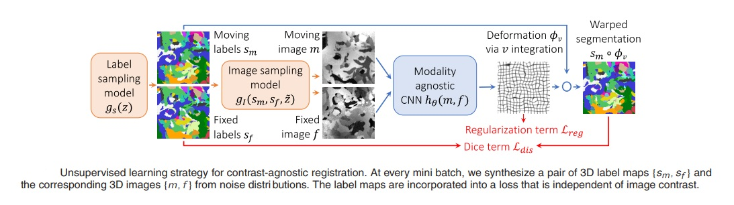

Figure XLV: Overview of SynthMorph

It would be interesting to incorporate Synthmorph into the image-guided robotics system and see if it could improve the image registration capabilities of the robotics system.

Lastly, a natural extension to the thesis project that could take another year or two would be to extend the image guided robotics system to 3 dimensions. Voxelmorph is based more on working with 3 dimensions instead of 2, which is why it is applied to medical imaging registration problems. 3D Slicer is also based on 3D rather than 2D. 3D Slicer usually takes a stack of images as input data, each representing a slice in a 3D model at a particular height and each separated by a constant offset. 3D Slicer is then able to create a 3D model out of the stack of 2D images. Most MRI and other medical imaging data is collected in this form, as a series of images rather than singular images. Instead of working on an image of an MRI scan, we could work with a 3D printed model of a human brain or some other object. The MoveIt code has capabilities of moving in 3 dimensions and it can also add obstacles to the planning scene that MoveIt takes into account and avoids. The object could be used as an obstacle, but at the same time we want to get as close to the model as possible. We can create a 3D reconstruction of the model in 3D Slicer using multiple single frame cameras or depth cameras. The depth cameras can return a point cloud and the model will be based upon the point clouds the depth camera sees. 3D reconstruction from multiple 2D images is possible using applications such as Blender, traditional non-machine learning based algorithms or deep learning based algorithms. A paper came out very recently (Mar 2022) that discussed “3D shape reconstruction from 2D Images with Disentangled Attribute Flow” [75] using 3DAttriFlow, a complicated deep learning pipeline that uses ResNet, Graph-Attention and MLPs and compares a ground truth result with an output point cloud. The architecture of 3D AttriFlow is shown in the figure below. The 3D reconstruction data can be loaded in 3D Slicer either as a model itself, or as a stack of 2D images like 3D Slicer expects.

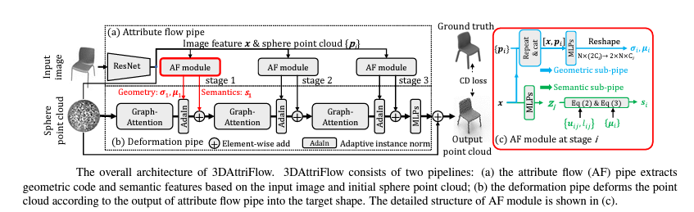

Figure XLVI: Overview of 3D AttriFlow

**6 References:**

[1] Connolly, L., Deguet, A., Leonard, S., Tokuda, J., Ungi, T., Krieger, A., ... & Taylor, R. H. (2022). Bridging 3D Slicer and ROS2 for Image-Guided Robotic Interventions. *Sensors*, *22*(14), 5336.

[2] Ginoya, T., Maddahi, Y., & Zareinia, K. (2021). A historical review of medical robotic platforms. *Journal of Robotics*, *2021*, 1-13.

[3] Bramhe, S., & Pathak, S. S. (2022). Robotic Surgery: A Narrative Review. *Cureus*, *14*(9).

[4] Cepolina, F., & Razzoli, R. P. (2022). An introductory review of robotically assisted surgical systems. *The International Journal of Medical Robotics and Computer Assisted Surgery*, *18*(4), e2409.

[5] Health, A. (2022, June 8). *Guided by surgeons, powered by Robots*. Adventist Health. Retrieved January 30, 2023, from https://www.adventisthealth.org/blog/2022/june/guided-by-surgeons-powered-by-robots/

[6] Google sites: Sign-in. (n.d.). Retrieved January 30, 2023, from https://sites.google.com/site/postgraduatetraining/image-acquisition/the-basics?tmpl=%2Fsystem%2Fapp%2Ftemplates%2Fprint%2F&showPrintDialog=1

[7] Frank, T., Krieger, A., Leonard, S., Patel, N. A., & Tokuda, J. (2017). ROS-IGTL-Bridge: an open network interface for image-guided therapy using the ROS environment. *International journal of computer assisted radiology and surgery*, *12*, 1451-1460.

[8] *3D slicer image computing platform*. 3D Slicer. (n.d.). Retrieved January 30, 2023, from https://www.slicer.org/

[9] George, E. I., Brand, C. T. C., & Marescaux, J. (2018). Origins of robotic surgery: from skepticism to standard of care. *JSLS: Journal of the Society of Laparoendoscopic Surgeons*, *22*(4).

[10] Nasab, M. H. A. (Ed.). (2019). *Handbook of robotic and image-guided surgery*. Elsevier.

[11] *The Da Vinciresearch Kit*. Intuitive Foundation. (n.d.). Retrieved January 30, 2023, from https://www.intuitive-foundation.org/dvrk/

[12] Says: ปั้มไลค์, says:, K. M. C., says:, V. A., & says:, M. H. (2019, August 9). *Joanna Szyman for PMR: Robotics - the future of surgery*. PMR Healthcare Market Experts. Retrieved January 30, 2023, from https://healthcaremarketexperts.com/en/news/joanna-szyman-for-pmr-robotics-the-future-of-surgery/

[13] U.S. Department of Health and Human Services. (n.d.). *Image-guided robotic interventions*. National Institute of Biomedical Imaging and Bioengineering. Retrieved January 30, 2023, from https://www.nibib.nih.gov/science-education/science-topics/image-guided-robotic-interventions

[14]

Marescaux, J., & Soler, L. (2004, June). Image-guided robotic surgery. In *Seminars in laparoscopic surgery* (Vol. 11, No. 2, pp. 113-122). Sage CA: Thousand Oaks, CA: Sage Publications.

[15] *6.1. registration intro¶*. 6.1. Registration Intro - MPHY0026 documentation. (n.d.). Retrieved January 30, 2023, from https://mphy0026.readthedocs.io/en/latest/registration/intro.html

[16] *, N. (2021, February 16). *Tutorial: 3D reconstructions using 3D slicer*. TVASurg - The Toronto Video Atlas of Surgery. Retrieved January 30, 2023, from https://pie.med.utoronto.ca/TVASurg/tutorial-3d-reconstructions-using-3d-slicer/

[17] Sarrut, D. (2006). Deformable registration for image-guided radiation therapy. *Zeitschrift für medizinische Physik*, *16*(4), 285-297.

[18] Liu, J., Singh, G., Al'Aref, S., Lee, B., Oleru, O., Min, J. K., ... & Mosadegh, B. (2019). Image registration in medical robotics and intelligent systems: fundamentals and applications. *Advanced Intelligent Systems*, *1*(6), 1900048.

[19] Han, J., Davids, J., Ashrafian, H., Darzi, A., Elson, D. S., & Sodergren, M. (2022). A systematic review of robotic surgery: From supervised paradigms to fully autonomous robotic approaches. *The International Journal of Medical Robotics and Computer Assisted Surgery*, *18*(2), e2358.

[20] T. (2019, May 20). *Level of autonomy for Surgical Robotics*. Level of Autonomy for surgical robotics. Retrieved January 30, 2023, from http://surgrob.blogspot.com/2019/05/level-of-autonomy-for-surgical-robotics.html

[21] Kumar, S., Singhal, P., & Krovi, V. N. (2015). Computer-vision-based decision support in surgical robotics. *IEEE Design & Test*, *32*(5), 89-97.

[22] Yang, L., & Etsuko, K. (2020). Review on vision‐based tracking in surgical navigation. *IET Cyber‐Systems and Robotics*, *2*(3), 107-121.

[23] *Endoscope - fertility*. MS Schippers. (n.d.). Retrieved January 30, 2023, from https://www.schippers.ca/en/endoscope-0010816.html

[24] AL-Azawi, M., Al-Rawy, D., Al-Jobory, S., Prof, A., Student, M., & Zaghar, D. (2019). Stereo vision for 3d measurement in robot systems.

[25] Berger, J., Unger, M., Keller, J., Reich, C. M., Neumuth, T., & Melzer, A. (2022). Design and validation of a medical robotic device system to control two collaborative robots for ultrasound-guided needle insertions. *Frontiers in Robotics and AI*, *9*, 875845.

[26] Berger, J., Unger, M., Landgraf, L., & Melzer, A. (2019). Evaluation of an IEEE 11073 SDC connection of two KUKA robots towards the application of focused ultrasound in radiation therapy. *Current Directions in Biomedical Engineering*, *5*(1), 149-152.

[27] *Depthai's documentation¶*. Luxonis. (n.d.). Retrieved January 30, 2023, from https://docs.luxonis.com/en/latest/

[28] *Realsense comparison¶*. RealSense comparison - DepthAI Hardware Documentation 1.0.0 documentation. (n.d.). Retrieved January 30, 2023, from https://docs.luxonis.com/projects/hardware/en/latest/pages/guides/realsense_comparison.html

[29] *Oak-D-lite¶*. D. (n.d.). Retrieved January 30, 2023, from https://docs.luxonis.com/projects/hardware/en/latest/pages/DM9095.html

[30] *Raspberry pi 4 model B 2019 Quad Core 64 bit WIFI bluetooth (4GB) : Amazon.ca: Electronics*. Raspberry Pi 4 Model B 2019 Quad Core 64 Bit WiFi Bluetooth (4GB) : Amazon.ca: Electronics. (n.d.). Retrieved January 30, 2023, from https://www.amazon.ca/Raspberry-Model-2019-Quad-Bluetooth/dp/B07TC2BK1X

[31] Ungi, T., Lasso, A., & Fichtinger, G. (2016). Open-source platforms for navigated image-guided interventions. *Medical image analysis*, *33*, 181-186.

[32] Rosmed. (n.d.). *Rosmed/slicer_ros2_module: Slicer module that can interface directly with Ros 2 using ROS parameters, topics, TF...* GitHub. Retrieved January 30, 2023, from https://github.com/rosmed/slicer_ros2_module

[33] *Franka control interface Documentation*. Franka Control Interface Documentation - Franka Control Interface (FCI) documentation. (n.d.). Retrieved January 30, 2023, from https://frankaemika.github.io/docs/index.html

[34] Frankaemika. (n.d.). *Franka_ros2/franka_description at develop · frankaemika/franka_ros2*. GitHub. Retrieved January 30, 2023, from https://github.com/frankaemika/franka_ros2/tree/develop/franka_description

[35] Frankaemika. (n.d.). *Frankaemika/Libfranka: C++ Library for Franka Emika Research Robots*. GitHub. Retrieved January 30, 2023, from https://github.com/frankaemika/libfranka

[36] *Ros 2 documentation*. ROS 2 Documentation - ROS 2 Documentation: Foxy documentation. (n.d.). Retrieved January 30, 2023, from https://docs.ros.org/en/foxy/index.html

[37] *Franka research 3*. Clearpath Robotics. (n.d.). Retrieved January 30, 2023, from https://store.clearpathrobotics.com/products/franka-research-3

[38] Ros-Controls. (n.d.). *Ros-controls/ros2_controllers: Generic robotic controllers to accompany ros2_control*. GitHub. Retrieved January 30, 2023, from https://github.com/ros-controls/ros2_controllers

[39] *MoveIt 2 tutorials*. MoveIt 2 Tutorials - MoveIt Documentation: Foxy documentation. (n.d.). Retrieved January 30, 2023, from https://moveit.picknik.ai/foxy/index.html

[40] *Move group C++ interface*. Move Group C++ Interface - MoveIt Documentation: Foxy documentation. (n.d.). Retrieved January 30, 2023, from https://moveit.picknik.ai/foxy/doc/move_group_interface/move_group_interface_tutorial.html

[41] *Moving robots into the future*. Brand. (n.d.). Retrieved January 30, 2023, from https://moveit.ros.org/

[42] *Rclpy¶*. rclpy - rclpy 0.6.1 documentation. (n.d.). Retrieved January 30, 2023, from https://docs.ros2.org/foxy/api/rclpy/index.html

[43] *The visualization toolkit*. VTK. (n.d.). Retrieved January 30, 2023, from https://vtk.org/

[44] *Cross-platform software design and Development Tools*. Qt. (n.d.). Retrieved January 30, 2023, from https://www.qt.io/

[45] *Slicer¶*. slicer. (n.d.). Retrieved January 30, 2023, from https://slicer.readthedocs.io/en/latest/developer_guide/slicer.html

[46] *Geometry_msgs/MSG/posearray message*. msg/PoseArray Documentation. (n.d.). Retrieved January 30, 2023, from https://docs.ros2.org/latest/api/geometry_msgs/msg/PoseArray.html

[47] *Touch*. 3D Systems. (2022, December 7). Retrieved January 30, 2023, from https://www.3dsystems.com/haptics-devices/touch

[48] Frankaemika. (n.d.). *Franka_ros2/franka_description at develop · frankaemika/franka_ros2*. GitHub. Retrieved January 30, 2023, from https://github.com/frankaemika/franka_ros2/tree/develop/franka_description

[49] *GNU/Linux Systems¶*. GNU/Linux systems - 3D Slicer documentation. (n.d.). Retrieved January 30, 2023, from https://slicer.readthedocs.io/en/latest/developer_guide/build_instructions/linux.html#build-slicer

[50] *Delft Haptics Lab*. "Phantom Omni" – 6 DOF master device | Delft Haptics Lab. (n.d.). Retrieved January 30, 2023, from https://delfthapticslab.nl/device/phantom-omni/

[51] Frankaemika. (n.d.). *Frankaemika/franka_ros2: Ros 2 integration for Franka Emika Research Robots*. GitHub. Retrieved January 30, 2023, from https://github.com/frankaemika/franka_ros2

[52] *Convert DAE to STL for free - imagetostl*. ImageToStl.com. (n.d.). Retrieved January 30, 2023, from https://imagetostl.com/convert/file/dae/to/stl

[53] RCLCPP: Rclcpp: Ros Client Library for C++. (n.d.). Retrieved January 30, 2023, from https://docs.ros2.org/foxy/api/rclcpp/index.html

[54] *Code API*. tf2: Main Page. (n.d.). Retrieved January 30, 2023, from https://docs.ros2.org/foxy/api/tf2/index.html

[55] *Orocos kinematics and dynamics*. KDL wiki | The Orocos Project. (n.d.). Retrieved January 30, 2023, from https://www.orocos.org/kdl.html

[56] *VTKMRMLNODE class reference*. Slicer. (n.d.). Retrieved January 30, 2023, from https://apidocs.slicer.org/v4.8/classvtkMRMLNode.html

[57] Luxonis. (n.d.). *Depthai-experiments/gen2-camera-demo at Gen2-RGB-depth-align · Luxonis/Depthai-Experiments*. GitHub. Retrieved January 30, 2023, from https://github.com/luxonis/depthai-experiments/tree/gen2-rgb-depth-align/gen2-camera-demo

[58] PointCloudLibrary. (n.d.). *Pcl/converter.cpp at master · pointcloudlibrary/PCL*. GitHub. Retrieved January 30, 2023, from https://github.com/PointCloudLibrary/pcl/blob/master/io/tools/converter.cpp

[59] Voxelmorph. (n.d.). *Voxelmorph/voxelmorph: Unsupervised Learning for Image Registration*. GitHub. Retrieved January 30, 2023, from https://github.com/voxelmorph/voxelmorph

[60] Gulhar, Abhinav, et al. "Registration of a robotic system to a medical imaging system." *2015 IEEE/RSJ International Conference on Intelligent Robots and Systems (IROS)*. IEEE, 2015.

[61] Gulhar, A., Briese, D., Mewes, P. W., & Rose, G. (2015, September). Registration of a robotic system to a medical imaging system. In *2015 IEEE/RSJ International Conference on Intelligent Robots and Systems (IROS)* (pp. 3208-3213). IEEE.

[62] Apriltag. (n.d.). Retrieved January 30, 2023, from <https://april.eecs.umich.edu/software/apriltag>

[63] “Papers with code - flyingthings3d dataset,” *Dataset | Papers With Code*. [Online]. Available: https://paperswithcode.com/dataset/flyingthings3d. [Accessed: 14-Apr-2023].

[64] “Harris corner detection,” *OpenCV*. [Online]. Available: https://docs.opencv.org/3.4/dc/d0d/tutorial_py_features_harris.html. [Accessed: 14-Apr-2023].

[65] S. A. K. Tareen and Z. Saleem, "A comparative analysis of SIFT, SURF, KAZE, AKAZE, ORB, and BRISK," 2018 International Conference on Computing, Mathematics and Engineering Technologies (iCoMET), Sukkur, Pakistan, 2018, pp. 1-10, doi: 10.1109/ICOMET.2018.8346440.

[66] “RPI 8MP camera board - raspberry pi camera board V2 ROHS compliant: YES,” *Newark*. [Online]. Available: https://canada.newark.com/raspberry-pi/rpi-8mp-camera-board/raspberry-pi-camera-board-v2-rohs/dp/32AJ8641. [Accessed: 14-Apr-2023].

[67] PXLAIRobotics, “PXLAIRobotics/ros2foxydocker: Base docker image with Ros 2 (Foxy Fitzroy),” *GitHub*. [Online]. Available: https://github.com/PXLAIRobotics/ROS2FoxyDocker. [Accessed: 14-Apr-2023].

[68] Thingiverse.com, “Raspberry-pi-7-inch-touch-screen-2020-or-wall-mount by growingsurvival,” *Thingiverse*. [Online]. Available: https://www.thingiverse.com/thing:4151849. [Accessed: 14-Apr-2023].

[69] A. Industries, “Adafruit Raspberry Pi Camera Board case with 1/4’ Tripod mount,” *adafruit industries blog RSS*. [Online]. Available: https://www.adafruit.com/product/3253. [Accessed: 14-Apr-2023].

[70] “Carr,” *McMaster*. [Online]. Available: https://www.mcmaster.com/. [Accessed: 14-Apr-2023].

[71] Hoffmann, M., Billot, B., Greve, D. N., Iglesias, J. E., Fischl, B., & Dalca, A. V. (2021). SynthMorph: learning contrast-invariant registration without acquired images. *IEEE transactions on medical imaging*, *41*(3), 543-558.

[72] *MNIST : tensorflow datasets*. TensorFlow. (n.d.). Retrieved April 14, 2023, from https://www.tensorflow.org/datasets/catalog/mnist

[73] Voxelmorph. (n.d.). *Voxelmorph/voxelmorph: Unsupervised Learning for Image Registration*. GitHub. Retrieved April 14, 2023, from https://github.com/voxelmorph/voxelmorph

[74] Hoopes, A., Hoffmann, M., Fischl, B., Guttag, J., & Dalca, A. V. (2021). Hypermorph: Amortized hyperparameter learning for image registration. In *Information Processing in Medical Imaging: 27th International Conference, IPMI 2021, Virtual Event, June 28–June 30, 2021, Proceedings 27* (pp. 3-17). Springer International Publishing.

[75] Wen, X., Zhou, J., Liu, Y. S., Su, H., Dong, Z., & Han, Z. (2022). 3D shape reconstruction from 2D images with disentangled attribute flow. In *Proceedings of the IEEE/CVF conference on computer vision and pattern recognition* (pp. 3803-3813).

**7 Appendix A (README File for Code):**

Turn on Franka Emika Panda robot, connect to robot network (PCI Ethernet Franka), go to https://172.16.0.2/desk/ to see the Franka Emika Panda robot interface, make sure robot is ready to run, and connect to robot using FCI mode. Compilation instructions: Open New Terminal (Terminal 1) source /opt/ros/foxy/setup.bash cd franka_ros2_ws colcon build --cmake-args -DSlicer_DIR:PATH=/home/medcvr/Slicer-SuperBuild-Debug/Slicer-build Raspberry Pi Instructions Plug in the power adapter and Ethernet cable. Make sure Ethernet cable is connected to the desktop computer. Go to Settings -> Network on the desktop computer and see if Pi is checked under Ethernet (enx00e04c0b24c1) in this case. SSH into Raspberry Pi On Desktop Computer Open New Terminal (Terminal 7) ssh medcvr@10.42.0.50 Look for Docker Containers running ROS2 Foxy (Reason is ROS2 Foxy is not compatible with the Ubuntu 22.04 LTS desktop installation on the Raspberry Pi) docker ps -a Look for Docker container called "inspiring_matsumoto" and copy its container ID. (In this case, container ID is e7f9e3c4cd8c) Open New Terminal (Terminal 8) ssh medcvr@10.42.0.50 docker start -i <container-id> (e7f9e3c4cd8c) cd home cd ros2_ws colcon build . install/setup.bash Check communication between Raspberry Pi Docker Container and Desktop Computer Open New Terminal on Desktop Computer (Terminal 9) source /opt/ros/foxy/setup.bash cd franka_ros2_ws ros2 run demo_nodes_cpp listener On Terminal 7: ros2 run demo_nodes_cpp talker Confirm messages are being recieved by the listener (Terminal 9) On Terminal 7: Run the Raspberry Pi camera node ros2 run camera_pub cam_pub Warning you must run this before you run Slicer otherwise it crashes When done using SSH: exit Load URDF in 3D Slicer: Open New Terminal (Terminal 2) source /opt/ros/foxy/setup.bash cd franka_ros2_ws source ~/franka_ros2_ws/install/setup.bash ros2 launch panda_model panda.launch.py (Write command but do not run until you see "Run command 1") Open New Terminal (Terminal 3) source /opt/ros/foxy/setup.bash cd franka_ros2_ws source ~/franka_ros2_ws/install/setup.bash ros2 run panda_model test_panda_joint_state_publisher (Write command but do not run until you see "Run command 2") Open New Terminal (Terminal 4) source /opt/ros/foxy/setup.bash cd Slicer-SuperBuild-Debug cd Slicer-build source ~/franka_ros2_ws/install/setup.bash Run 3D Slicer: ./Slicer Note that the first time you run Slicer, you need to add the module directory should be in the application settings so that it can be loaded. To do so, open Slicer and navigate through the menus: Edit -> Application Settings -> Modules -> Additional module paths -> Add: ~franka_ros2_ws/build/slicer_ros2_new/lib/Slicer-5.1/qt-loadable-modules At that point, Slicer will offer to restart. Do so and then load the module using the button Modules -> Examples -> Ros2. The module's interface will appear on the left side of Slicer. You should leave the first two drop-down menus as-is, i.e. State should be tf2 and Description should be parameter. The defaults /robot_state_publisher and robot_description should work for most cases so leave these as-is too. Now, Run command 1 Run command 2 To display the Franka Emika Panda robot in 3D Slicer, just hit "Enter" in the /robot_state_publisher box. At that point, the robot's model should be loaded and displayed in Slicer. Once the robot is displayed in 3D Slicer, kill the 2 nodes in the terminal (Ctrl+C). This step is required to show the robot in 3D Slicer because it is used to load the robot STLs in 3D Slicer and to read the robot URDF. Reuse Terminal 2 ros2 launch franka_bringup franka.launch.py robot_ip:=<fci-ip> use_rviz:=true (For lab, <fci-ip> = 172.16.0.2) This runs the launch file that can be used to start the robot without any controllers. There is no controller running apart from the joint_state_broadcaster which the program uses to broadcast the position of the robot in 3D Slicer. However, a connection with the robot is still established and the current robot pose is visualized in RViz. In this mode the robot can be guided when the user stop button is pressed. However, once a controller that uses the effort_command_interface is started, the robot will be using the torque interface from libfranka. Reuse Terminal 3 To control the robot in FCI mode without running the code but still seeing the robot model update in 3D Slicer, you can use these commands: It is possible to launch the gravity_compensation_example_controller by running: ros2 control load_controller --set-state start gravity_compensation_example_controller When the controller is stopped with: ros2 control set_controller_state gravity_compensation_example_controller stop the robot will stop the torque control and will only send its current state over the FCI. You can now choose to start the same controller again with: ros2 control set_controller_state gravity_compensation_example_controller start or load and start a different one: ros2 control load_controller --set-state start move_to_start_example_controller ros2 control load_controller --set-state start joint_impedance_example_controller More information at https://support.franka.de/docs/franka_ros2.html#moveit These commands are good for manuveuring the robot in FCI mode before and after running the code and seeing the robot model update in 3D Slicer. Optional (MoveIt Interface) You can use the MoveIt interface to plan trajectories and command the robot to move in 3D Slicer Kill franka_bringup node (Terminal 2) Open New Terminal source /opt/ros/foxy/setup.bash cd franka_ros2_ws source ~/franka_ros2_ws/install/setup.bash To see if everything works, you can try to run the MoveIt example on the robot: ros2 launch franka_moveit_config moveit.launch.py robot_ip:=<fci-ip> (For lab, <fci-ip> = 172.16.0.2) Then activate the MotionPlanning display in RViz. Path Following Code Open New Terminal (Terminal 5) source /opt/ros/foxy/setup.bash cd franka_ros2_ws source ~/franka_ros2_ws/install/setup.bash ros2 launch franka_slicer_moveit moveit.launch.py robot_ip:=<fci-ip> use_gripper:=false (For lab, <fci-ip> = 172.16.0.2) Open New Terminal (Terminal 6) source /opt/ros/foxy/setup.bash cd franka_ros2_ws source ~/franka_ros2_ws/install/setup.bash ros2 launch franka_slicer_moveit trace_path_moveit.launch.py Path Following Code (3D Slicer Module Interface): Create desired paths to trace using markups. Select desired path to trace in the selection box labelled "Markup" and press the "Add To Path" button to add the markup path to the overall path. Continue adding markup paths as desired. The robot will trace each markup in order, going back to the home position after each markup. Press the "Trace Path" button when you have added the desired markup paths and the robot will trace all of them. Open New Terminal (Terminal 9) source /opt/ros/foxy/setup.bash cd franka_ros2_ws source ~/franka_ros2_ws/install/setup.bash ros2 run image_reg img_reg Once you start this node, the first image it recieves will be the fixed image.